Dear Parents/ Carers,

It has been lovely to meet and get to know all our new children.
Our topic this term is ‘All about Me’ – Each day, we will discuss new emotions or potential worries: Friends, Family, Things we like to do, Places we like to go. This topic allows us to get to know the children well and gives them the opportunity to talk about things they like and dislike, their families and things they enjoy doing.
If your child has any allergies or dietary requirements, please ensure this is all on Arbor as soon as possible.
If your child is to be collected by someone different to usual, please message us on Dojo!
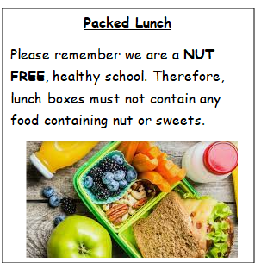
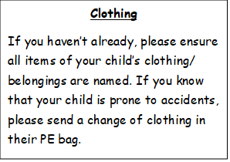

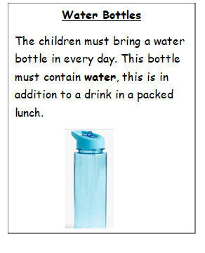
Reading Books- Will be sent out later in the term.
Important dates
- 1st October 2025: Individual photos
- 9th October 2025: Harvest carousel PM (Time to be confirmed)
- 14th and 15th of October 2025: Parents evening
- 28th - 1st November half term

Please don’t forget to sign up to our class Dojo!
Thank you so much for your support,
The Reception Team
This term in the following areas we are learning to…

Personal, Social and Emotional Development
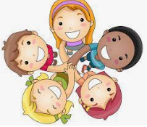
- To describe and show friendly behaviour.
- To begin taking turns with their friends.
- Begin to develop friendships with other children within the setting.
- Select and use activities and resources, with help when needed from an adult
- Express their feelings and manage their own needs.
- Be confident to try new activities and show independence
- Understanding the importance of healthy food choices.

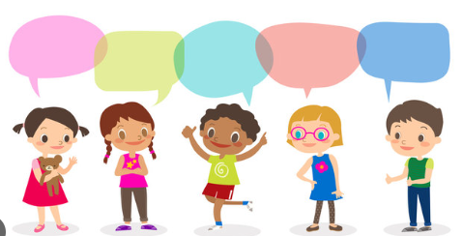
Communication and Language
- To know about others.
- To know familiar songs.
- To describe different story and non-fiction texts.
- Listen to simple stories and understand what is happening with the help of the pictures.
- Understand and act on longer sentences
- Engage in story times.
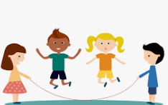
Physical Development
- Gross motor skills: Negotiate space and obstacles safely, with consideration for themselves and others; Move energetically, such as running, jumping, dancing.
- Fine motor Skills: Experience activities to develop finger muscle strength such as dough disco, clever fingers.

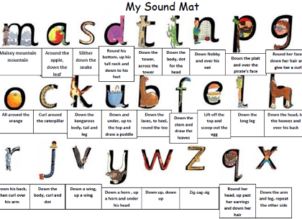
Literacy / phonics
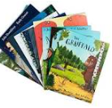
- Read first 16 Set 1 sounds Learn to blend: Word Time 1.1 to 1.3 Spell using Fred Fingers
- Shows awareness of rhyme and alliteration.
- Joins in with repeated refrains and anticipates key events and phrases in rhymes and stories.
- Interest in illustrations and print in books and print in the environment.
- To copy letter shapes which are familiar to them e.g. from their name.
- To give meaning to the marks they make as they write.
- To copy taught shapes and letters.
- To write the initial sounds in words.
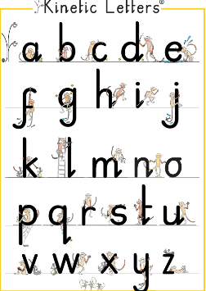
- Begin to form lower case letters correctly
- Emergent writing opportunities in play e.g. lists, cards

Maths
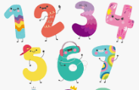
- 1:1 counting.
- Recognising and ordering numbers to 10.
- Formation of written numbers.
- Subitising.
- Counting groups of objects.
- 2D Shapes
- Pattern.


Understanding the World
Key focus points this term:
- People, Culture and Communities
- UTW: The Natural World
- Ourselves

- To know the names of body parts.
- To identify and sort healthy/unhealthy foods.
- To identify and group a range of fruits and vegetables.
- Comment on images of familiar situations in the past.
- Talk about members of their immediate family and community.
- Name and describe people who are familiar to them.
- Recognise some similarities and differences between religions.
- Explore the natural world around them.
- Being aware of changes that happen throughout the year (e.g. seasons, nature).
- Recognising significant dates for them (birthday).
- Beginning to use common words and phrases for the passage of time, even if using inaccurately (e.g. yesterday, today, tomorrow, last week, “when I was in nursery…”
- Making simple observations about the past from photographs and images.
Expressive Arts and Design
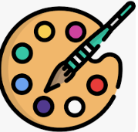
- Name simple instruments
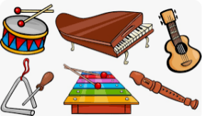
- Investigate marks and patterns when drawing.
- Identify similarities and difference between
- drawing tools.
- Investigate how to make large and small
- movements with control when drawing.
- Practise looking carefully when drawing
- Combine materials when drawing.

Here is to a happy and successful first term at school!

