English

In English, we will be continuing our RWInc programme to learn all our phonic sounds.
This will be our main focus for all our English learning this term.
Below are the set 1 sounds and the rhymes that we use to help your children write the letter.
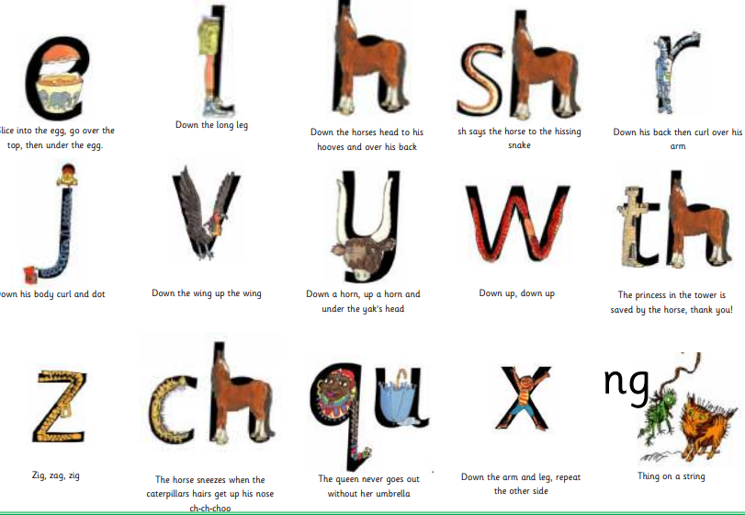
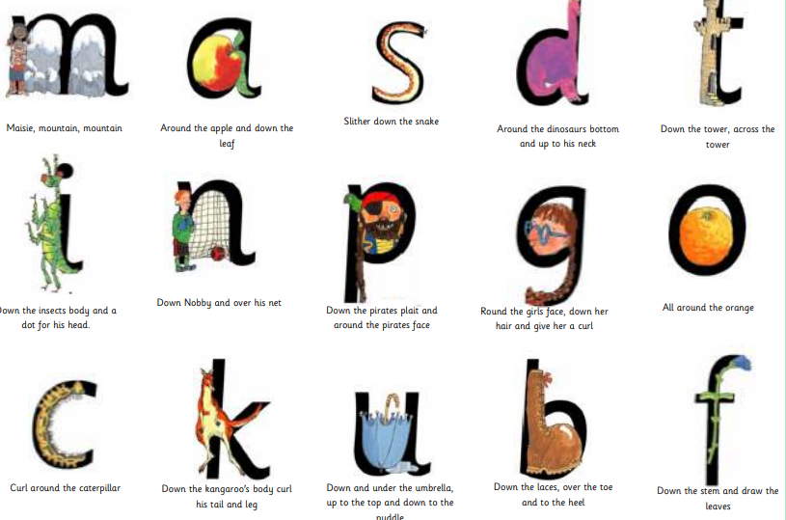

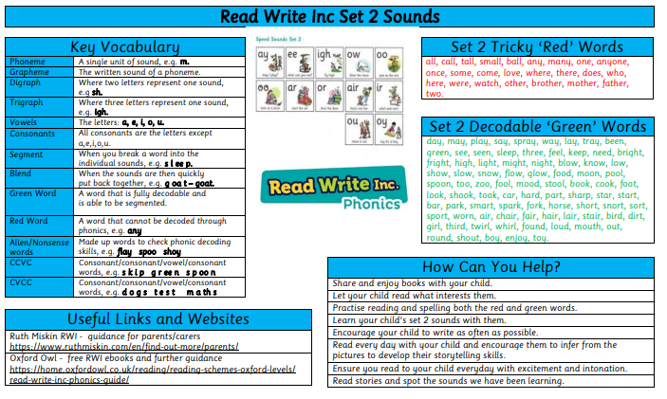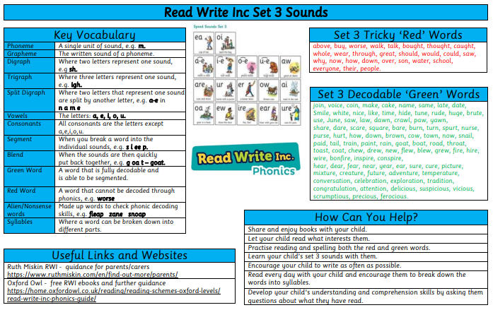

In Maths, we are focusing on place value within 10. We will be sorting and counting objects, learning to recognise one more and one less than a given number and using the number line. We will learn new maths vocabulary including fewer, more, the same and less than, greater than and equal to.

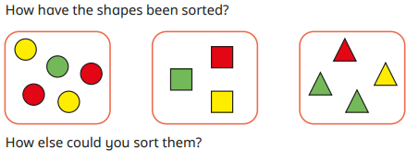
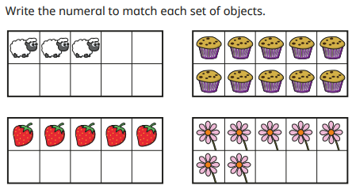

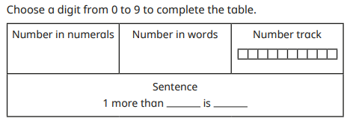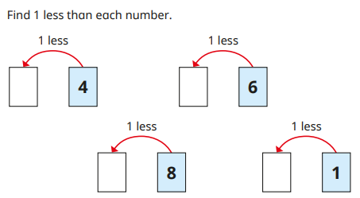
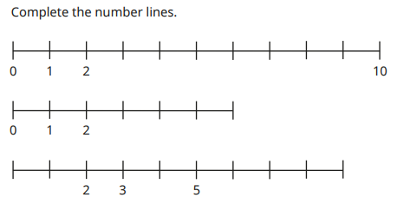
Mathematics
This term we will be learning about ourselves! We will be learning about our bodies and thinking about how we use our senses.
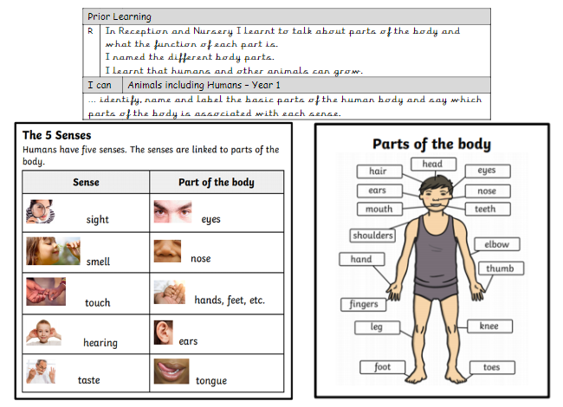

COMPUTING
Computer systems and networks
In this unit, we will develop our understanding of technology and how it can help us. We will start to become familiar with the different components of a computer by developing our keyboard and mouse skills. We will also think about how to use technology responsibly.
PSHE
What is the same and different about us?
We are thinking about what we like/dislike and are good at, what makes us special and how everyone has different strengths and how we are similar or different to others, and what we have in common. we are similar or different to others, and

RE
Belonging
We will learn about belonging and how religious people show that they belong to their faith community.
We are learning about belonging. You will learn about how religious people show they belong to their faith community. They will learn about ways babies are welcomed in religions and the promises made at weddings. They will think about their own network of belonging and how we all belong to someone.

In history we become detectives to develop an understanding of personal chronology and to learn more about our own personal history. We will also explore how we remember events, what childhood was like for our parents and grandparents, compare childhood now with childhood in the past and identify that somethings change and some things stay the same.
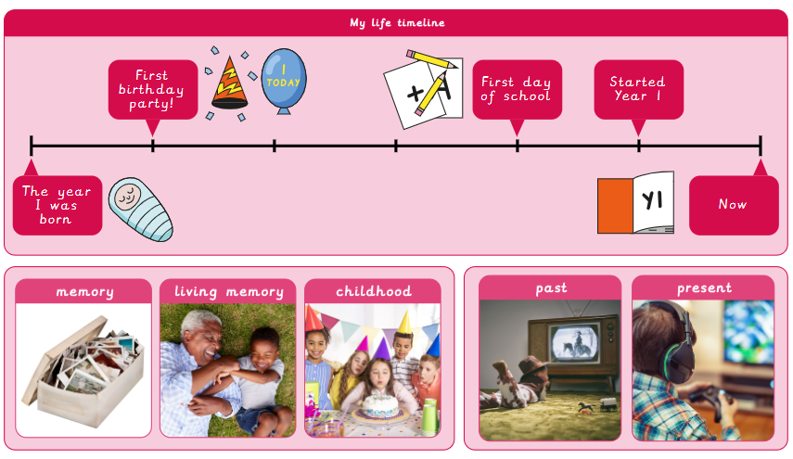

DT
Stable Structures-Making a Pencil Pot
We will learn that structures are things that are built and have a purpose. We will explore that structures with a wider base are more stable than ones with a narrow base and choose the best method for joining the parts of the product.

PE
Fundamentals
We will explore the fundamental skills of balancing, running, changing direction, jumping, hopping, and skipping. We will explore these skills in isolation as well as in combination. with others.
Team Building
We will develop our teamwork skills. We will work individually, in pairs and in small groups, learning to take turns, work collaboratively and lead each other. We will develop key skills of communication and problem solving. We are looking forward to exploring team building activities in the forest!

