English

In English, we will be continuing our RWInc programme to learn all our phonic sounds.
Below are the set 1 sounds and the rhymes that we use to help your children write the letter.
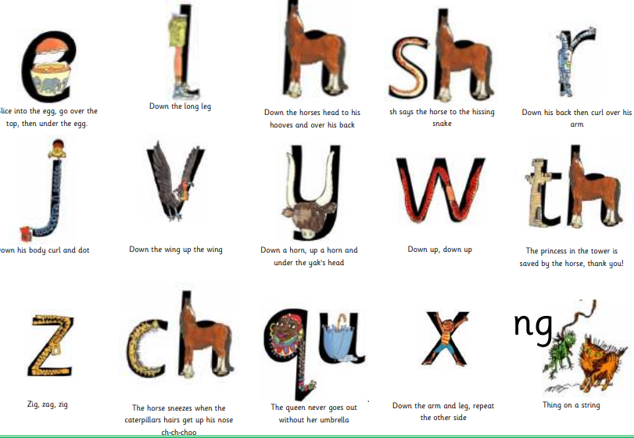
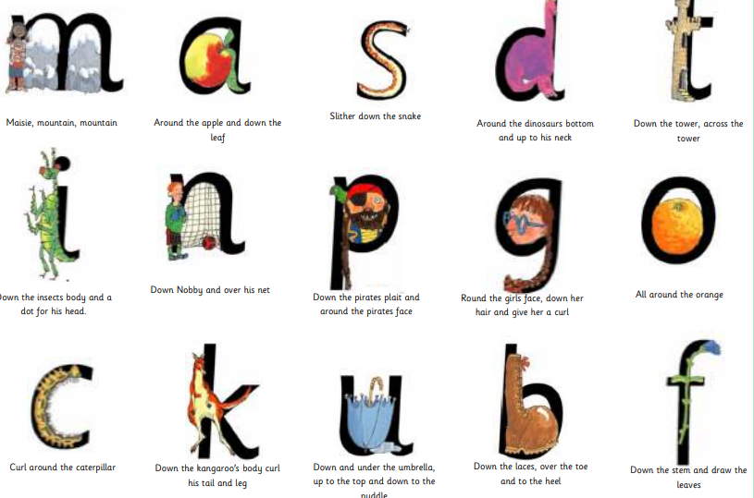

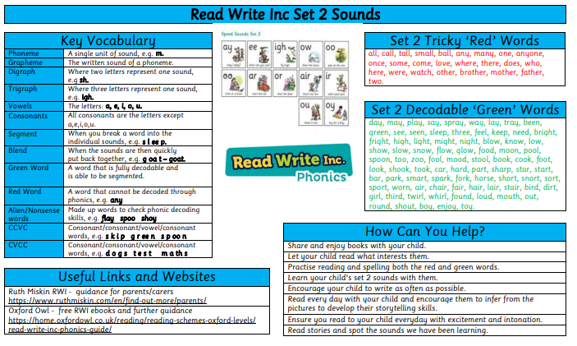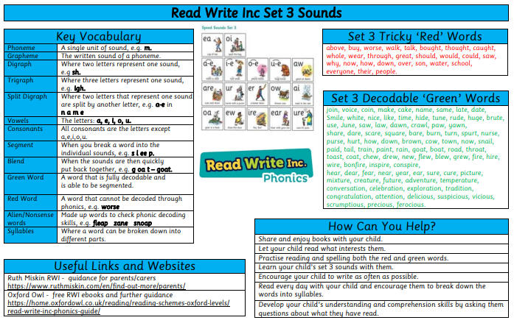
In Maths, we will be focusing on place value within 20, continuing to work on our number fluency. We will be ordering, comparing and estimating using different manipulatives to support our learning. We will continue to develop our knowledge of more and less. We will also focus on addition and subtraction within 20 including doubles and near doubles, number bonds to 20, finding the difference and missing number problems. We will use reasoning and problem-solving questions to support our developing maths mastery.

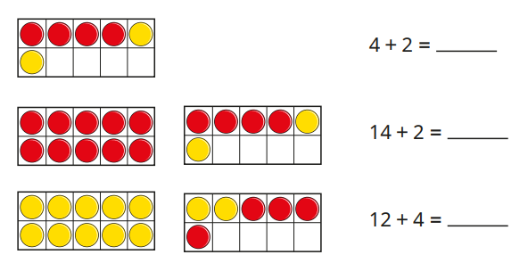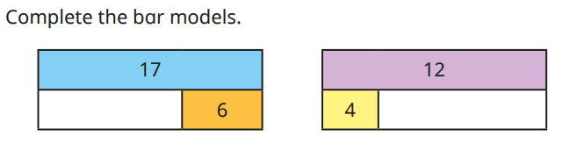
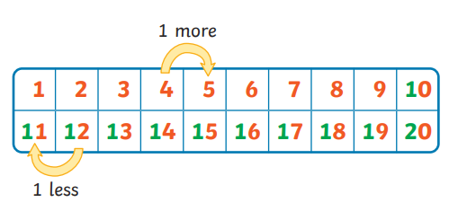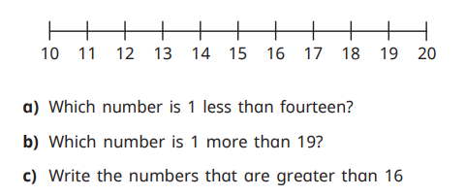

The children will continue to use their rekenreks to develop their understanding of number concepts.
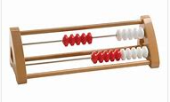

Mathematics
SCIENCE
Everyday Materials
We will identify, name, group and describe a variety of everyday materials, including wood, plastic, glass, metal, water, and rock. We will learn to distinguish between an object and the material from which it is made.
We will continue to develop our knowledge of seasonal change, focusing on Winter.

PSHE
This term we are looking at relationships. We will be thinking about our families, including talking about different members of our family, discussing how we share common features across families and sharing different activities our families enjoy.
COMPUTING
Programming Beebots
We will be learning about early programming concepts. We will learn to:
Use individual commands as part of a computer program.
Explore what each floor robot command does and use that knowledge to start predicting the outcome of programs.
Create our own algorithms to move a beebot.

ART
PAPER PLAY
We will be introduced to paper-based 3D art forms, focusing on techniques like rolling paper tubes, shaping paper strips, and constructing imaginative sculptures.

PE
ATHLETICS
In this unit we will develop the skills required in running at different speeds, changing direction, throwing and jumping. We will compete to improve on our own score and against others

FITNESS
We will develop our understanding of the benefits of exercise and a healthy body on our physical body, mood and overall health.

HISTORY
How have toys changed?
Sequencing toys into a physical timeline, we investigate artefacts from the past and begin to pose questions. We learn how teddy bears have changed and ‘interview’ an old teddy bear before considering what toys may be like in the future.

RE
Who is Christian and what do they believe?
This term we will begin to understand what Christians believe about God and about Jesus as the Son of God. This unit looks at stories about Jesus and stories that Jesus told.

MUSIC
Body Percussion and untuned Percussion
We will perform a range of body percussion using hands and other parts of the body. We will create a rainstorm using body percussion that includes dynamic contrast. We will learn to perform using graphic notation.

