English

In English, we will be continuing our RWInc programme to learn all our phonic sounds.
This will be our main focus for all our English learning this term.

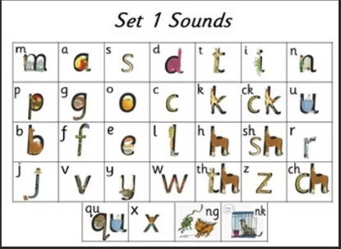

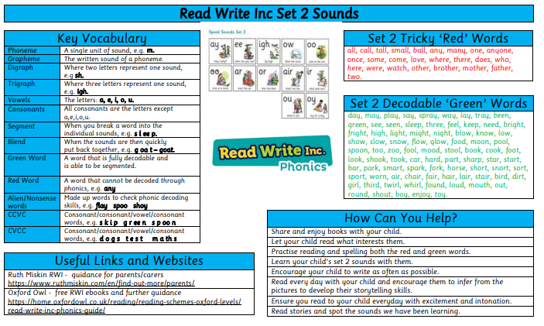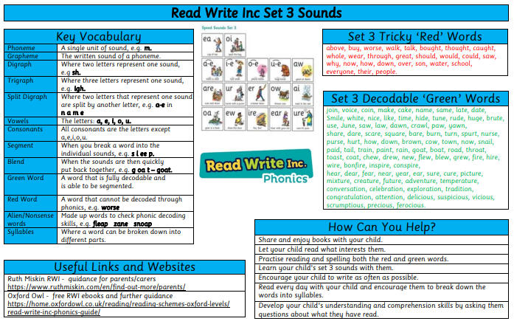
English
Mathematics
In Maths, we will be starting our addition and subtraction unit using a variety of resources to demonstrate our understanding. We will focus on using part-part whole, number sentences, fact families and the number line. We will also complete our first shape unit focusing on recognising and naming 2-D and 3-D shapes and creating patterns.

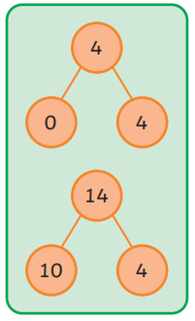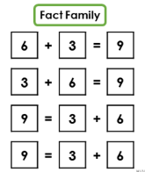

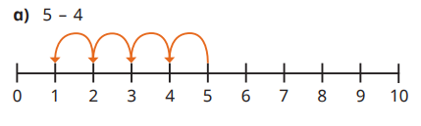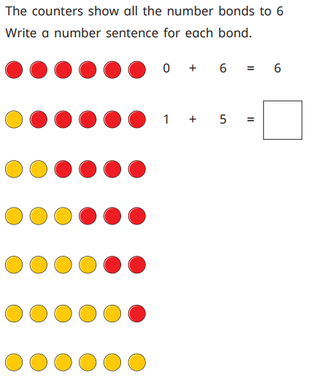

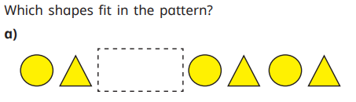

Science
In Science, we will continue to learn about animals, including humans, with a focus on animals. We will identify and name a variety of common animals that are birds, fish, amphibians, reptiles and mammals. We will also sort animals into groups of carnivores, herbivores and omnivores.
We be investigating the weather and seasons by observing what is happening around us during the Autumn. We will name the four seasons in order: Spring, Summer, Autumn, Winter and investigate rainfall and temperature.
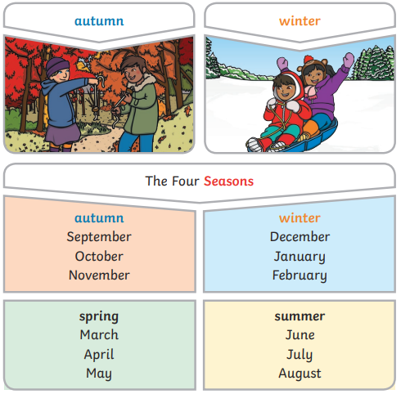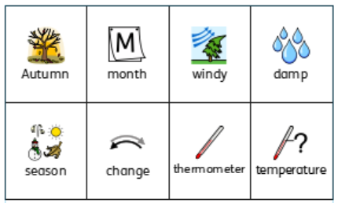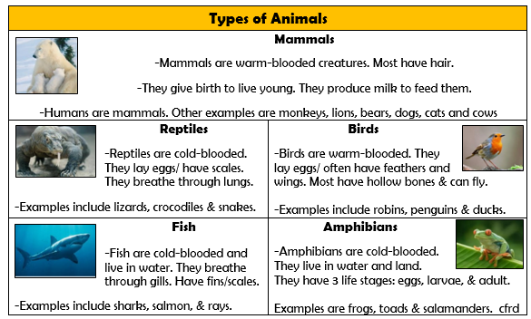

Geography
What is it like here?
We will be locating where we live on an aerial photograph and recognising features within our local area. We will learn to create maps using classroom objects before drawing simple maps of the school grounds. We will follow simple routes around the school grounds and carry out an enquiry as to how our playground can be improved.

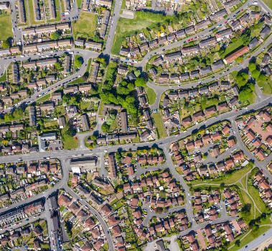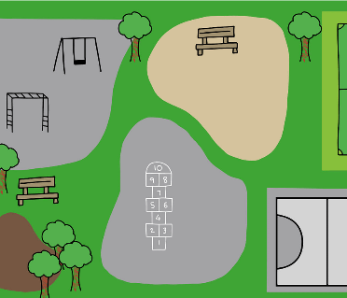

RE
Belonging
This term we will continue to learn about belonging and how religious people show that they belong to their faith community.
We will also learn about Christmas.

COMPUTING
Digital Painting
During this unit, learners develop their understanding of a range of tools used for digital painting. They then use these tools to create their own digital paintings, while gaining inspiration from a range of artists’ work.
PSHE
What helps us stay healthy
This term we will be learning about what and who helps us stay healthy, that things people put in their bodies can affect how they feel and hoe medicines can help us.

PE
Gymnastics
We will use space safely and effectively, explore and develop basic gymnastic actions on the floor and using low apparatus. Basic skills of jumping, rolling, balancing and travelling are used individually and in combination to create movement phrases.

Ball Skills
We will explore and develop throwing and catching, rolling and dribbling, with both hands and feet.

ART
Drawing: exploring line and shape
We will be exploring line and shape by working and experimenting with different materials through observational and collaborative pieces inspired by artists.

MUSIC
We will be keeping the beat/ pulse, experiencing different tempo and beginning to think about rhythm.

