Cecil Road Nursery and Primary School.
Year 3, Term 3, 2026

In mathematics this term, the main two topics we will be covering are Multiplication and Division as well as Length and Perimeter.
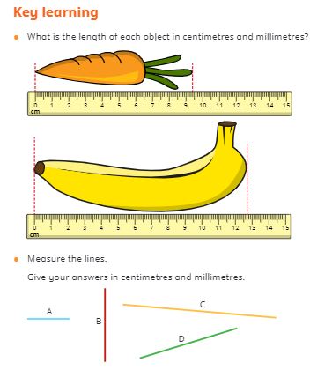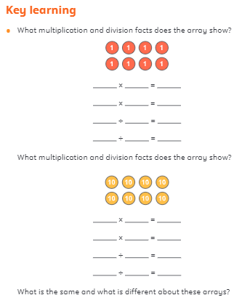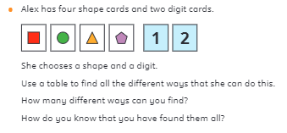
We will also be concentrating on learning the 3, 4 and 8-times tables.
We will continue to use TTrockstars on a regular basis and would like you to continue the great work/progress at home.

We will also be starting TTRockstars https://play.ttrockstars.com/auth/school/student/42278 We will be setting 1x, 2x, 3x, 4x, 5x and 10x from here this term.

Mathematics

In English our writing genres will be Reports and Narrative
Writing Genre: | Reports | Narrative
Work: | We will be writing a non-chronological report on the Roman Army. We will be researching facts, planning and writing our report. | We will be writing our own stories based on the book ‘The Last Zookeeper’ By Aaron Becker.. We will be planning, our stories and using our descriptive writing skills to write our own stories.
Main skills covered | Using conjunctions: when, if, because, although.  Using a heading and subheadings. | Descriptive writing, use of adjectives and adverbs, using conjunctions and fronted adverbials, and expanded noun phrases.
Ways to help at home: | Try using the conjunctions orally in a sentence. | When reading at home describe the characters in the book. What do we mean by a setting and using
Spelling: This term we will be covering:
- Starting to learn the Y3 and 4 common exception words
- Guided Reading: Our guided reading book this term will be The Fatal Fire by Terry Deary. It is a Roman Tale linked to this term’s topic. We will be making predictions about what we think will happen, summarising key events and answering retrieval questions about the characters, plot and setting. With home reads please also ask your child lots of questions about what they think is going to happen, ask them to sum up what they have read and also ask questions about the characters and setting.
English

Other Subjects: During the term:
In PSHE we will be learning about families. In music we will be continuing with our recorder lessons.
In RE will be answering the question – What do people believe about God?
PE will be on Monday and Thursday.



