Cecil Road Nursery and Primary School.

Mathematics

In mathematics this term, we will be continuing with addition and subtraction of 3-digit numbers with regrouping, moving from concrete representations using place value counters and base 10 equipment, onto a more abstract written method as well as looking at multiplication and division.
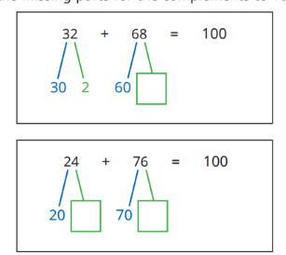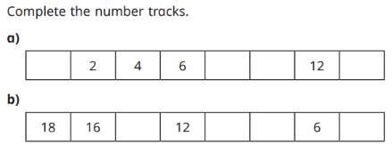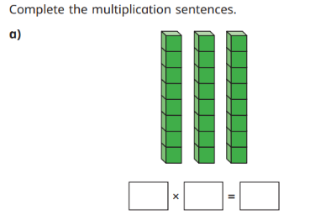

We will also be continuing with TTRockstars https://play.ttrockstars.com/auth/school/student/42278 where children can practise their times tables.

Year 3, Term 2, 2025-2026

In English our writing genres will be non-chronological reports and poetry
Writing Genre: | Non-Chronological Reports | Poetry
Work: | We will be finding out about Penguins which will link to our Antarctica theme. | We will be reading and writing Winter poems.
Main skills covered | - Write question sentences.  - Conjunctions  - Grouping related facts.  - Choosing the right subheading.  - Writing in note form.  - Using bullet points.  - Write a non-chronological report | - Write a poem based on the theme of Winter  - Write a poem or rhyme, saying it aloud first  - Use adjectives to describe nouns  - Use powerful verbs  - Use similes  - Use adverbs  - Use repetition  - Perform a poem with clear fluency and expression
Ways to help at home: | Research facts about Emperor Penguins at home.  Make a fact file and bring to school. | Share a selection of poems with your child.  Discuss how they are similar or different to a story or non-fiction book.

Spelling: This term we will be: Adding -ation, ch spelt ch, sh spelt ch, adding -ian, adding -ion, adding -re
Guided Reading: Our guided reading book this term will be The Emperor’s Egg by Martin Jenkins
We will be making predictions about what we think will happen, summarising key events and answering retrieval questions about the characters, plot and setting.
Reading at home: Support your child’s learning by reading daily and checking your child’s understanding of the text. Our move to Accelerated Readers puts a lot more emphasis on their understanding of the books they are reading and they will be tested on their books before moving on to a new one.
Other Subjects: In Music we will be continuing our weekly Recorder lessons taught by Mr Patterson from Kent Music School. In art, we are studying sculpture and 3D. Our Geography topic is “Who lives in Antarctica?” Our computing topic is Desktop Publishing. In PSHE, we are asking “What keeps us safe?” In RE, wea re finding out about different celebrations. Our science topic is Forces and Magnets.
PE will be every Monday and Thursday so please make sure kits are in school on these days. This term we are focussing on Rugby and Yoga.

English

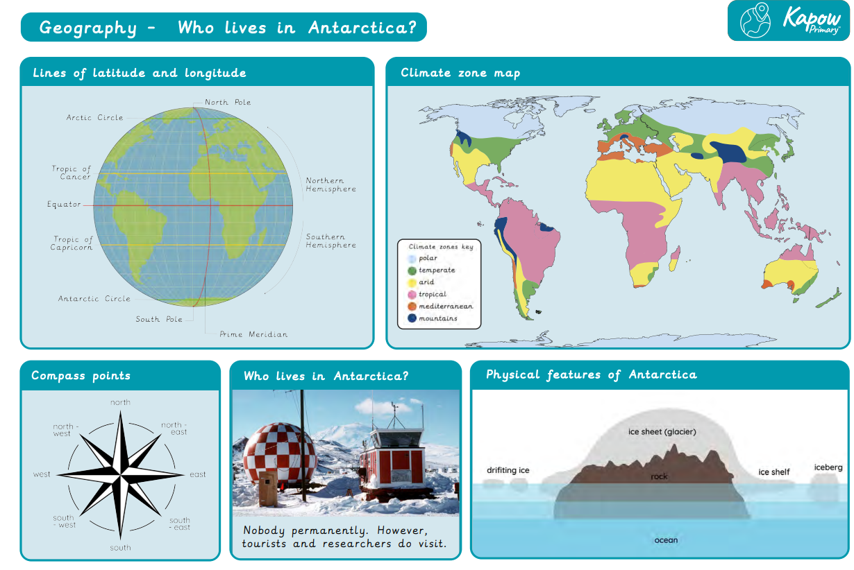
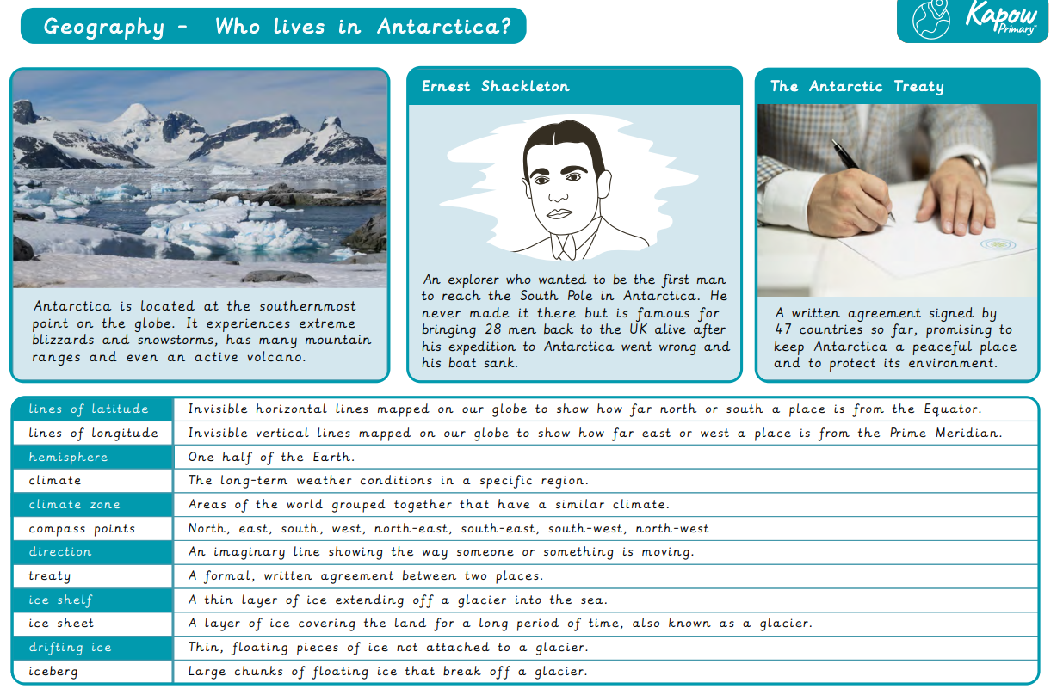

Y3 – Forces and Magnets
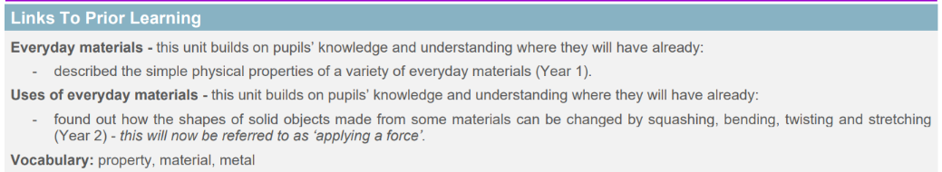
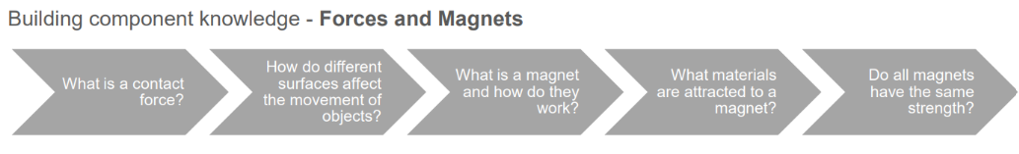
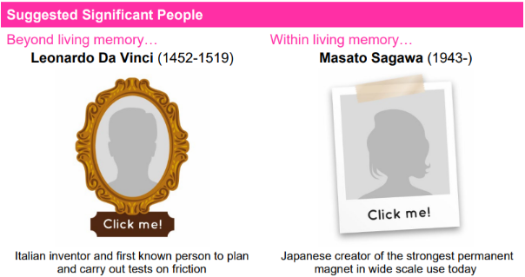
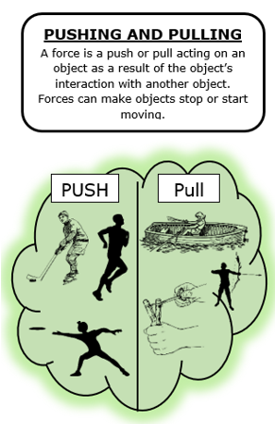
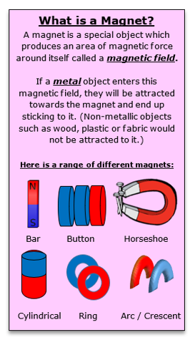
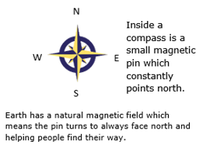

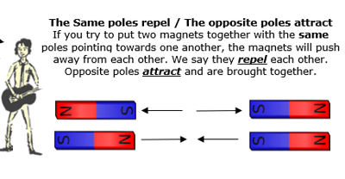

Key Vocabulary
Push | Attract | Steel
Pull | repel | nickel
Surface | North/South pole | Contact/non-contact force
Movement | Metal | Friction
magnet | iron | resistance

