English
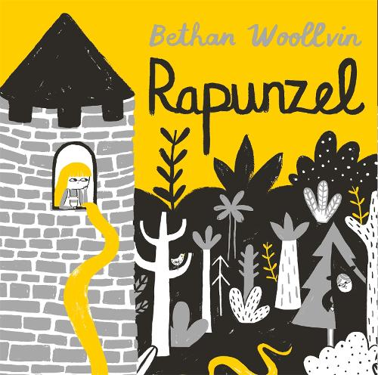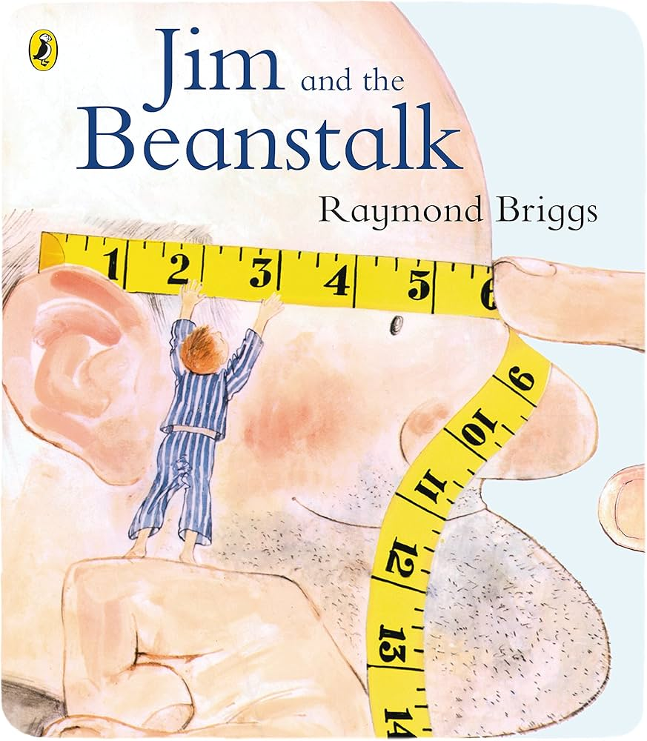
In English, we will be basing our work around ‘Rapunzel’ by Bethan Woollvin. This book is a retelling of the traditional story. Golden-haired princess Rapunzel is kept trapped in her lofty tower by a wicked witch, who cuts off her beautiful hair and sells them for money. Can Rapunzel ever figure out a way to escape? During our writing lessons, we will be looking at describing the character and the setting. Later in the term, we will look at Jim and the Beanstalk by Raymond Briggs. We will use both texts to focus on sentence structure and what it means to make a sentence.
To support your child’s reading and writing development, at home you can:
-listen to your children read often at home (the more children read, the more they are exposed to the correct structure of sentences to support their writing and the more vocabulary they will pick up.)
-show children the importance of reading (take trips to the library, talk to them about what you like to read, enjoy books together, listen to audiobooks.)

For Guided Reading, we will be following the Talk through Stories programme. Each week we will be reading a different story and practising our reading skills. Guided Reading lessons focus on 8 main reading skills. These are: vocabulary, reading fluency, retrieval (remembering information from the text), inference (discussing and understanding what has happened in the text and why), prediction, summarising, making connections (linking it to other things they know/have read) and author’s choice (identifying how the author’s choices effect the reader/text.)

All the children will be starting on the RWI Spelling Programme. We will be sending home spelling words each week, please practice these spellings with your child. The RWI Spelling Programme involves learning green words to practice spelling patterns and Year 2 red (common exception) words.
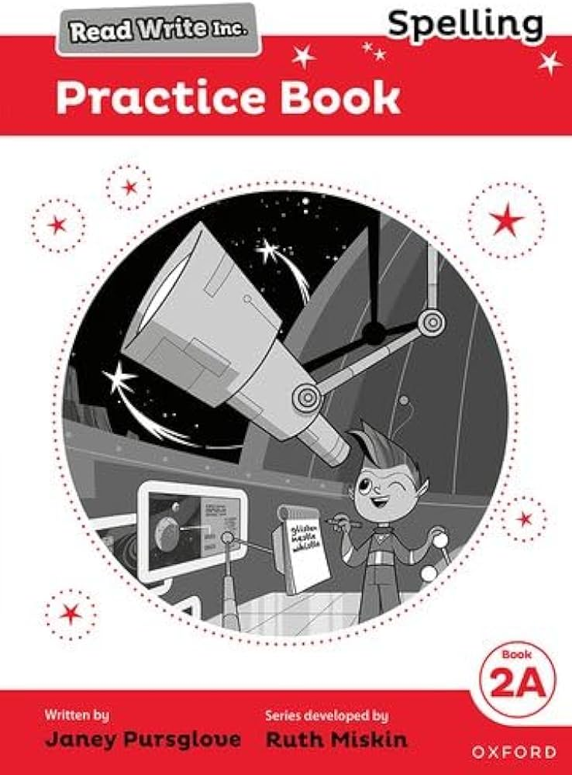
Mathematics
In Maths, we will be consolidating our Year 1 place value work. Then, moving on to developing our knowledge of whole numbers – saying and understanding what each digit represents in a 2-digit whole number. We will also partition a 2-digit number in different ways, using a variety of resources to demonstrate of understanding.

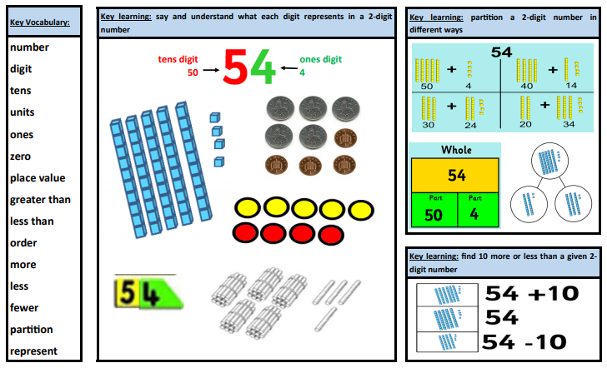
We will also start recapping our Year 1 knowledge and understanding of addition and subtraction.
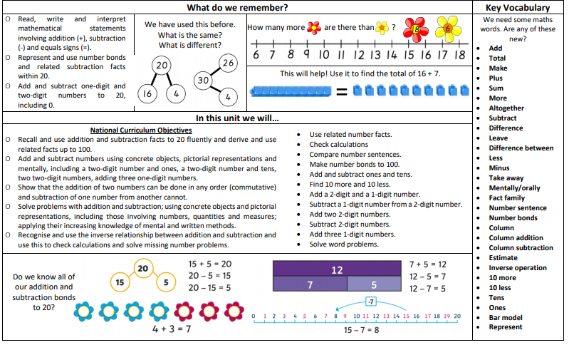
History will be the main theme leading other curriculum learning during the term.
How was school different in the past?

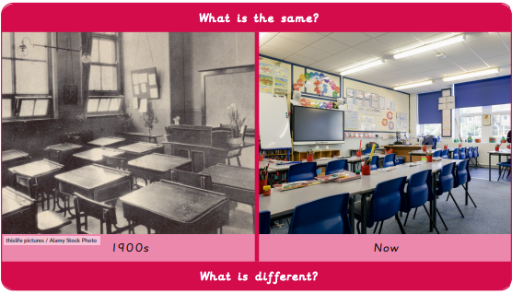
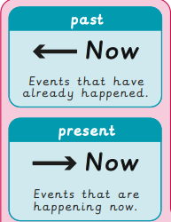
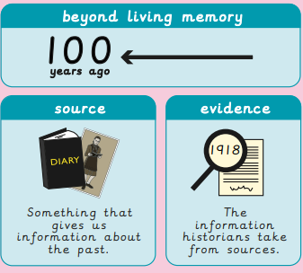
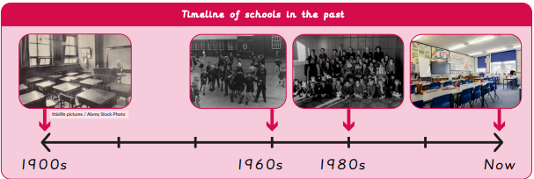
Science

Science Knowledge Organiser:
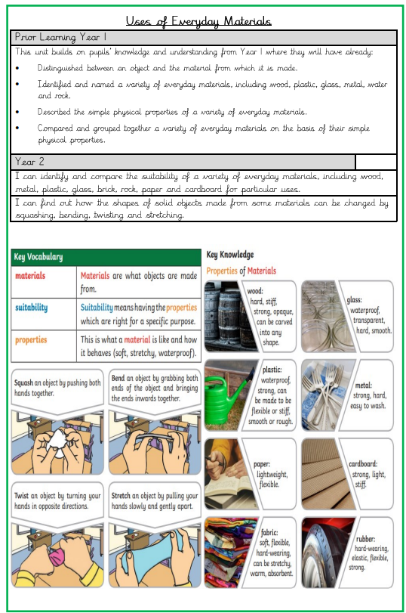

PSHE
What helps us grow and stay healthy?
In this unit, children will understand:
-that different things help their bodies healthy.
-that eating and drinking too much sugar can affect their health.
-how to be physically active and how much rest and sleep they should have every day.
-that there are different ways to learn and play; how to know when to take a break.
-how sunshine helps our bodies.
RE
How should we care for others and the world, and why does it matter?
Whilst exploring this enquiry question, children will learn in depth about the Christian and Jewish ways of life and beliefs. They will listen to different religious stories and discuss its meanings and teachings.
Music
Mars by Holst
Listening to music and creating rocket music.
Art
Drawing: Tell a story
This unit focuses on helping pupils develop their ability to tell a story through drawing. It includes lessons on creating textures, observational drawing, character expression, and storytelling through illustrations, enhancing pupils’ mark-making techniques, observational skills, and imagination in art.
PE

Swimming (Thursday - Johnson)
This term Johnson class will be swimming in the afternoons.

Dance (Thursday – indoor)
In this unit, children will explore space and how their body can move to express an idea, mood, character or feeling. Children will explore pathways, levels, shapes, directions, speeds and timing. They will work independently and with others.

Fundamentals (Friday - outdoor)
In this unit, pupils will develop the fundamental skills of balancing, running, changing direction, jumping, hopping and skipping. Pupils will be given opportunities to work with a range of different equipment.
DT
Cooking and nutrition: A balanced diet.
In this unit the children will learn about the importance of a balanced diet and creating a tasty, balanced wrap to meet a design brief. They will be able to name the main food and identify foods that belong to each group. Additionally, they will describe the taste, feel and smell of a given food. Finally, the children will construct their own wrap using the design brief.

Computing
Computer systems and networks – Information Technology around us.
Learns will develop their understanding of what Information Technology (IT) is and will begin to identify examples. They will discuss where they have seen IT in school and beyond, in settings such as shops, hospitals, and libraries. Learners will then investigate how IT improves our world, and they will learn about the importance of using IT responsibly.

