Welcome to Term 3! We hope you all had a restful break and enjoyed this festive period with your loved ones. We have many exciting things planned for this term!
Forest School:
It is time for Forest School! Here is a reminder of the key dates:
Johnson  08/01/2026  15/01/2026  22/01/2026  29/01/2026  05/02/2026  12/02/2026 | Attenborough  09/01/2026  16/01/2026  23/01/2026  30/01/2026  06/02/2026  13/02/2025

Attendance Matters:
Attendance is really important and valued at Cecil Road Primary and Nursery School. Every day is an opportunity for children to grow both academically and socially. We are asking you to support your children by ensuring that they attend school every day that they can. Please arrange appointments and visits for after school, at the weekends or during the school holidays.

Year 2’s attendance 93.5%

English
Writing
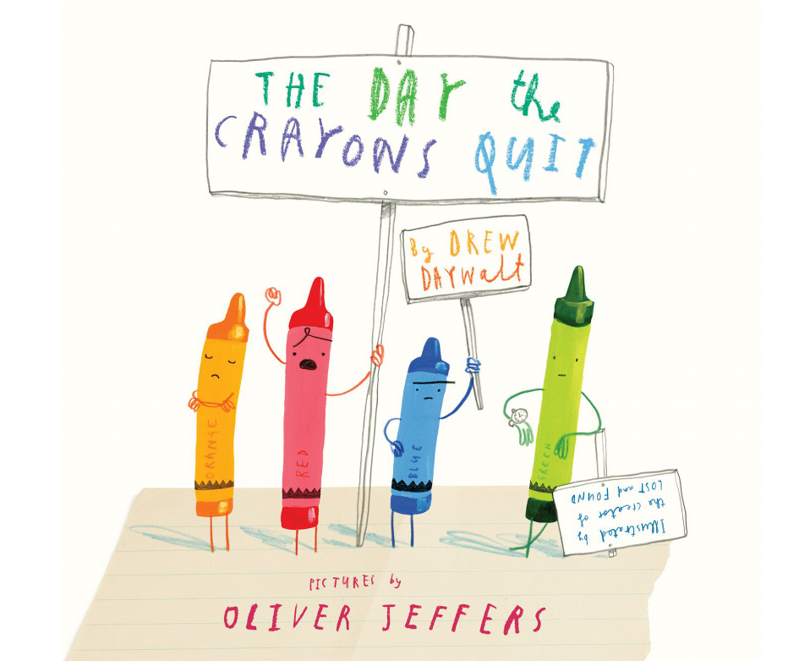
In English, we will be using ‘The Day the crayons quit’ by Drew Daywalt, as our focus text. This is a fantastically funny picture book about crayons writing letters to their owner about how they are used. The text is a great model example of how to use exclamation marks and questions marks which is a year 2 writing target. The children will be writing their own letters to themselves as if they were their crayons.
We will then be writing information booklets about forest school. They will focus on using conjunctions to join their sentences and extend their writing.

SPaG this term will be taught daily and a copy of each unit of spellings will be sent home in the children’s contact book for you to practice together. Spelling lists are also set on Doodle for the children to practice further.

Reading
In Guided Reading, we will exploring various short stories to help develop our retrieval skills. The children will continue to develop their fluency skills by reading longer texts more independently. They will then practice locating and recording information from various sources.
The children have been engaging with Accelerated Reader amazingly last term and we hope this continues into the new year. Please do read with your children regularly, even if they are confident readers it is always useful to discuss what has been read.
In Maths, we will be consolidating our knowledge of 2D and 3D shape.
Then, we will be developing our knowledge and understanding of multiplication and division.
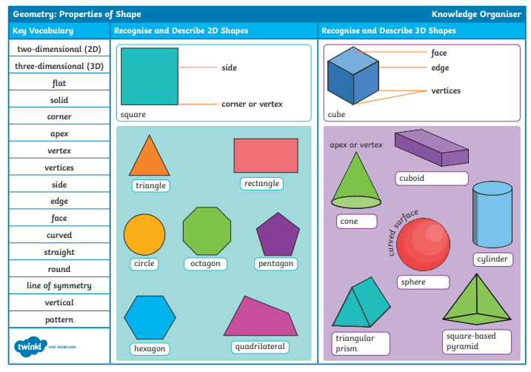
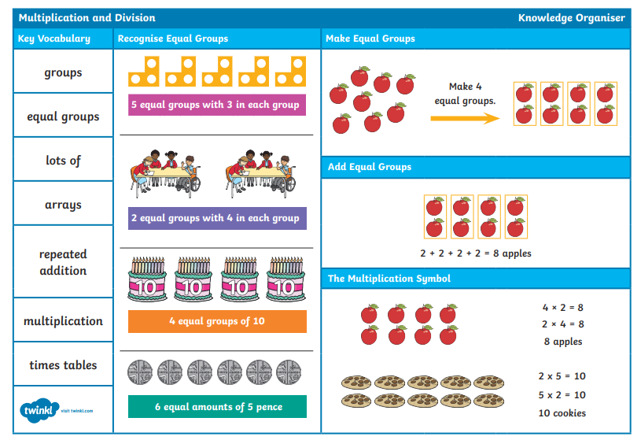
Mathematics
How did we learn to fly?
History will be the main theme leading other curriculum learning during the term.

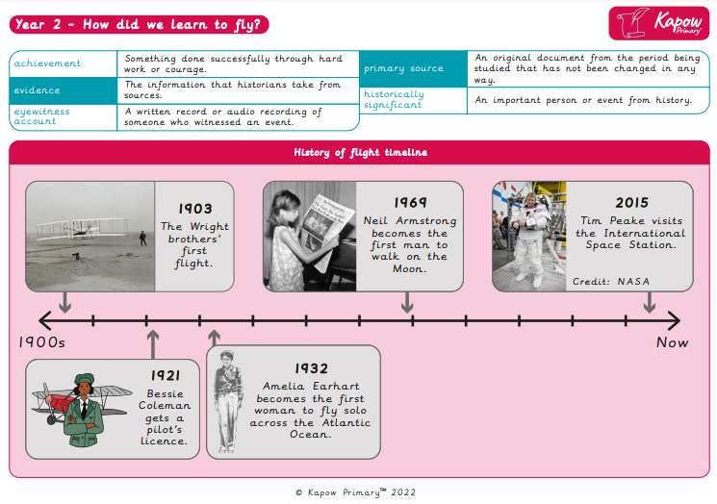

Science

Y2 – Uses of everyday materials
Prior Learning
1 | - Distinguish between and object and the material from which it is made.  - Identify and name a variety of everyday materials, including wood, plastic, glass, water and rock.  - Describe the simple physical properties of a variety of everyday materials.  - Compare and group together a variety of everyday materials on the basis of their physical properties.
I can |  | Uses of everyday materials – Year 2
- Identify and compare the suitability of a variety of everyday materials, including wood, metal, plastic, glass, brick, rock, paper and cardboard for particular purposes
- Find out how the shapes of solid objects made from some materials can be changed by squashing, bending, twisting and stretching.
Vocabulary (word) | Definition (meaning)
materials | what objects are made from
properties | what a material is like
suitability | if it’s right for a certain purpose
investigate | to find out about

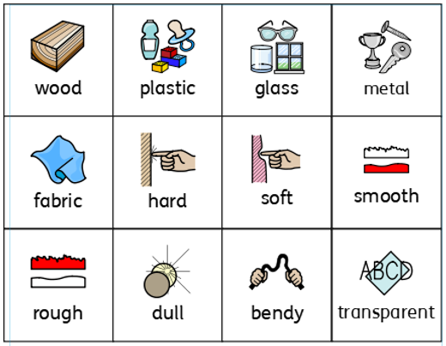
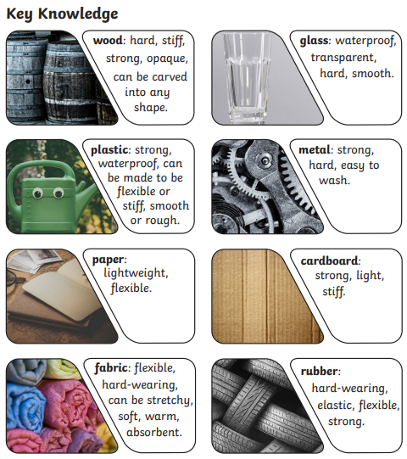

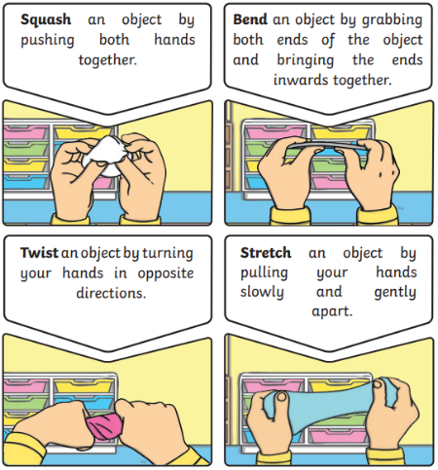

PSHE
What makes a good friend?

We will learn about:
How to make friends with others.
How to recognise when you feel lonely and what to do about it.
How people behave when they are being friendly and what makes a good friend.
How to resolve arguments that can occur in friendships.
How to ask for help if a friendship is making you unhappy.

RE
Who is Jewish and what do they believe?
You will learn to:
Talk about how the mezuzah in the home reminds Jewish people about God.
Ask good questions about how Jewish artefacts are used and their meaning.
Talk about how Shabbat is a special day of the week for Jewish people.
Give some examples of what Jewish people might do to celebrate Shabbat.
Re-tell a story that shows what Jewish people at the festivals of Chanukah might think about
God, suggesting what it means.
COMPUTING
Digital Photography

Through the lessons, you will learn to recognise that different devices can be used to capture photographs and will gain experience capturing, editing, and improving photos. Finally, you will use this knowledge to recognise that images they see may not be real.
Music
I’ve got rhythm!
You will learn about rhythm and how to notate it.

PE
Dance (inside – Monday)
In this unit pupils will explore space and movement. They will be using their bodies to explore a mood, character or feeling.

Fundamental (outside – Wednesday)
In this unit pupils will explore the fundamental skills of balancing, running, changing direction, jumping, hopping and skipping. They will explore these skills in isolation as well as in combination. Pupils will be given opportunities to identify areas of strength and areas for improvement.

Art
Painting and mixed media: Life in colour
This unit focuses on teaching primary and secondary colours, colour mixing, and creating textures using different tools. It also covers collage techniques, encouraging pupils to experiment with materials and evaluate their artistic choices and aims to develop children's understanding of colour, texture, and composition in art. Use this unit hub to inform your medium-term plan and to navigate to related resources.

