English
In English this term, we will continue to develop our sentence structure writing. We will be exploring information texts about the Arctic and Antarctica and will develop our use of commas for lists and conjunctions. We will then be learning the story ‘Dasher’. It is a wonderful story about how Santa came to have his Christmas reindeers; we will write our own versions of the narratives. Then we will finish this term by making some delicious rocky roads and will write detailed recipes on how you can do them at home too!

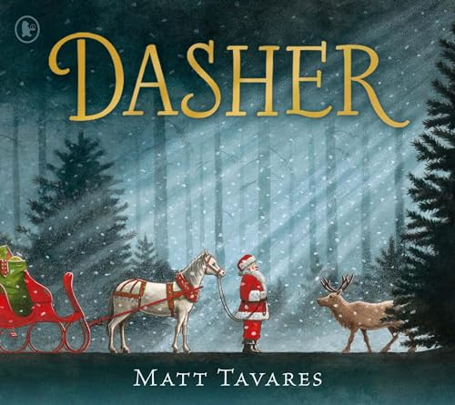
Our guided reading lessons focusing on 8 main reading skills: vocabulary, reading fluency, retrieval (remembering information from the text), inference (discussing and understanding what has happened in the text and why), prediction, summarising, making connections (linking it to other things they know/have read) and author’s choice (identifying how the author’s choices effect the reader/text). We will be exploring various texts, including ‘Voices in the park’.
We will be continuing our daily SPAG (spelling and grammar) lessons. Our spelling lists for this term are as follows. These will also be stuck into your child’s contact book.
2A Unit 5 word list | 2A Unit 6 word list | 2A Unit 7 word list | 2A Unit 8 word list
badly  coolly  gladly  bravely  foolishly  happily  kindly  nearly  quickly  loudly  normally  quietly  sadly  snugly  stupidly  slowly  softly  warmly  weakly  weekly | gnarl  gnat  gnome  gnash  gnaw  knead  knee  knew  knight  kneel  knife  knit  knock  know  knuckle  knot | butterfly  cry  fly  by  dry  horrify  July  my  petrify  multiply  nearby  rely  reply  shy  sly  satisfy  sky  spy  terrify  why  try | putting  chatting  dropping  beginning  clapping  drumming  flapping  gripping  knotting  grabbing  humming  nodding  patting  running  shrugging  prodding  shopping  slipping  splitting  tripping  stopping  trotting

In Maths, we will be developing our knowledge of addition and subtraction.
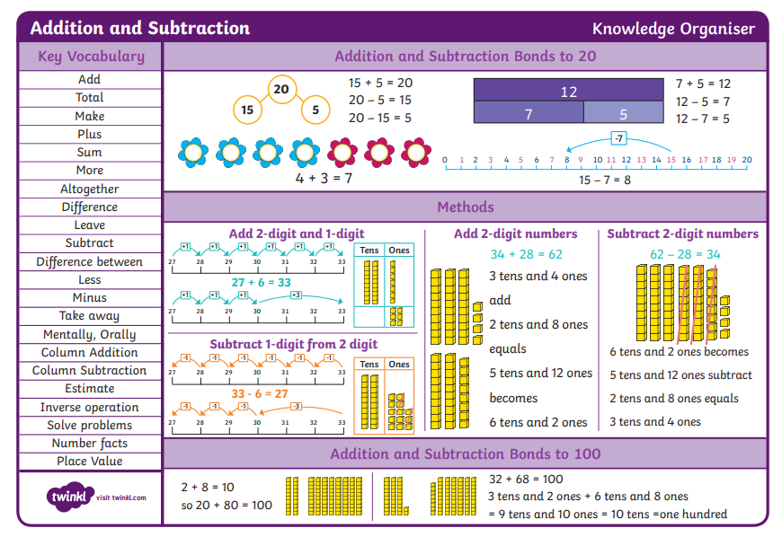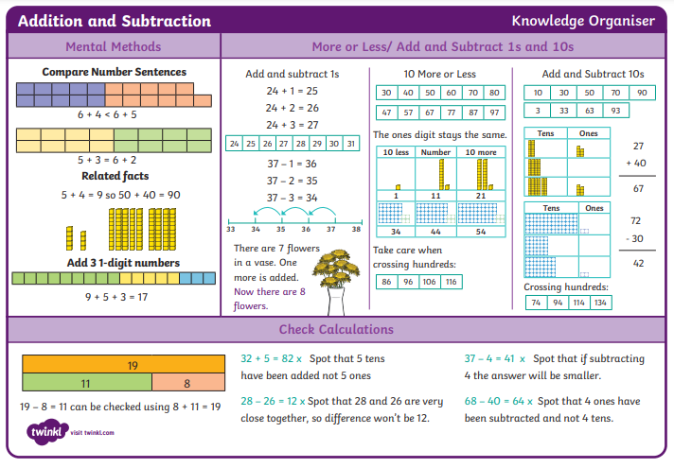
Mathematics
Would you prefer to live in a hot or cold place?
Geography will be the main theme leading other curriculum learning during the term.

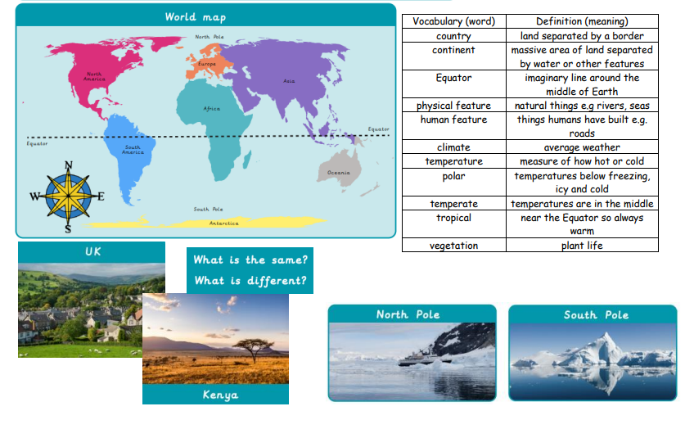

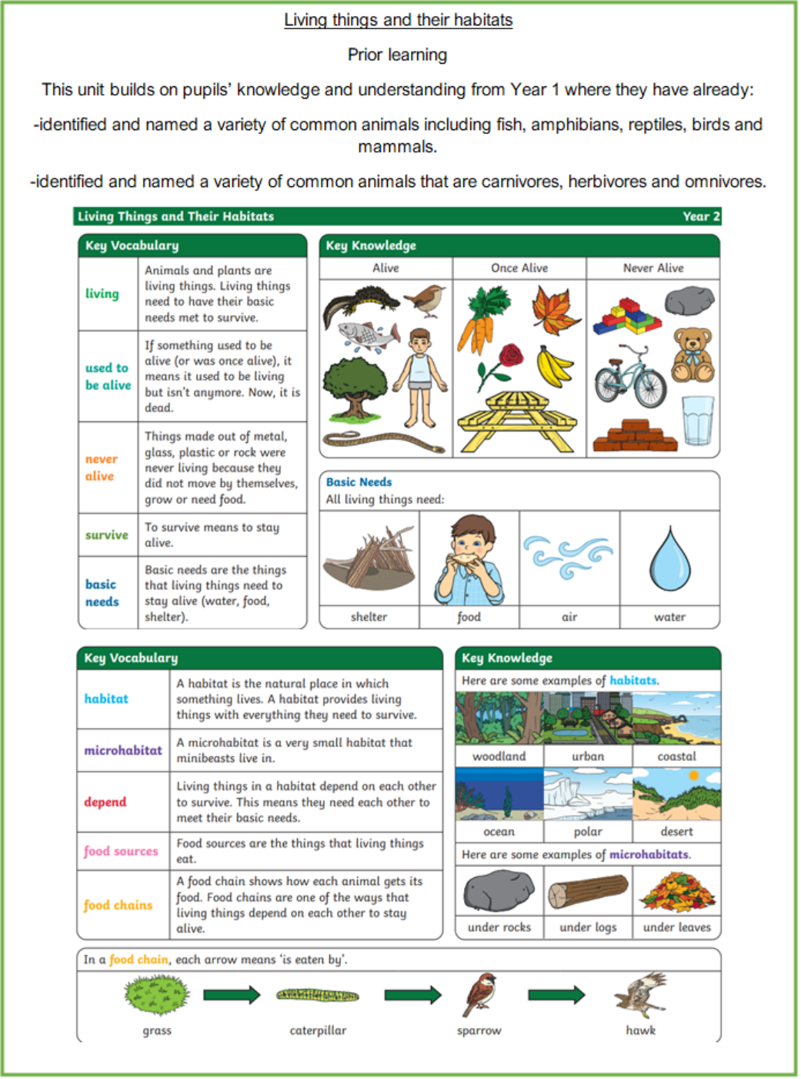
Science

RE
How and why do we celebrate special and sacred times?
You will learn to:
-Identify some ways Christians celebrate Christmas/Easter/Harvest/Pentecost and some ways a festival is celebrated in another religion.
-Re-tell stories connected with Christmas/Easter/Harvest/Pentecost and a festival in another religion and say why these are important to believers.
-Ask questions and suggest answers about stories to do with Christian festivals and a story from a festival in another religion.
-Collect examples of what people do, give, sing, remember or think about at the religious celebrations studied, and say why they matter to believers.

PSHE
How do we recognise our feelings?
We will learn about:
-how to recognise and describe feelings.
-what helps us to feel good or better.
-how different experiences can bring about different feelings.
-how feelings can affect people in their bodies and their behaviour.
-ways to manage big feelings and the importance of sharing our feelings with someone we trust.
-how to recognise when we might need help with feelings and how to ask for help when we need it.
COMPUTING
Robot algorithms
This unit develops pupils’ understanding of instructions in sequences and the use of logical reasoning to predict outcomes. Pupils will use given commands in different orders to investigate how the order affects the outcome. Pupils will also learn about design in programming. They will develop artwork and test it for use in a program. They will design algorithms and then test those algorithms as programs and debug them.

PE
Target games (outside – Wednesday)
Target games are games where players send an object towards a target. It could be while avoiding obstacles, getting closer to a target than an opponent or by hitting a target in the fewest turns. It could also be a moving target. Examples of target games are dodgeball., golf, curling, boccia, archery, bowling.
Striking and Fielding (outside – Friday)
Striking and fielding games are games where there are two teams, one, the batting team, try to score points and the other, the fielding team, try to stop the batting team from scoring. Examples of striking and fielding games include cricket and rounders.

MUSIC
Swing on Shostakovich
You will learn to:
Find the beat and mark it with body percussion.

DT
Structures: Baby Bear’s chair
You will learn to:
Explore the concept and features of structures and the stability of different shapes.
Understand that the shape of the structure affects its strength.
Make a structure according to design criteria.
Produce a finished structure and evaluate its strength, stiffness and stability.

