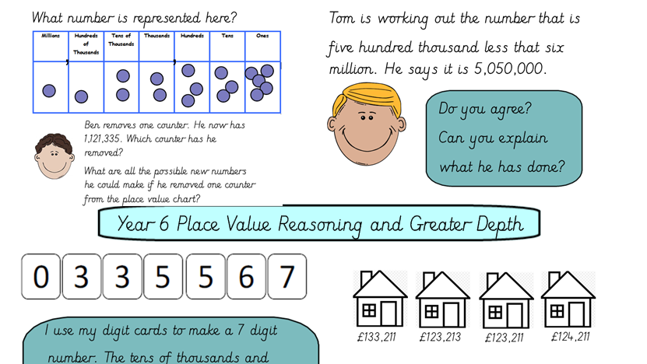
First look at the number of counters in each place value column. Make sure you read the numbers from the left. Then write the number in numerals: 1,122,335. You can also write it in words: one million, three hundred and twenty-two thousand, three hundred and thirty-five. Notice that the thousands are written together.
Mathematics
Cecil Road Nursery and Primary School
Year 6 Term 1, 2024-2025

In mathematics this term, the main two topics we will be covering are place value within 10,000,000 and the four operations. When studying place value, we will also look at ordering and comparing, rounding and negative numbers. We will be using place value charts to help us throughout the unit.
.

Practice of number bonds will really benefit pupils with + and -. A good website to practice these is https://www.topmarks.co.uk/maths-games/hit-the-button If you cluck on number bonds and go to the addition and subtraction within 20 sections..
We will also be starting TTRockstars https://play.ttrockstars.com/auth/school/student/42278 We will be setting 1x, 2x, 3x, 4x, 5x and 10x from here this term.

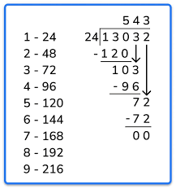
We will look at a range of different methods that we can use when multiplying and dividing numbers with more that 2-digits.
When ordering and comparing, you need to look at the place value column that is furthest to the left. Then you need to compare the numbers in each column; moving towards the right.
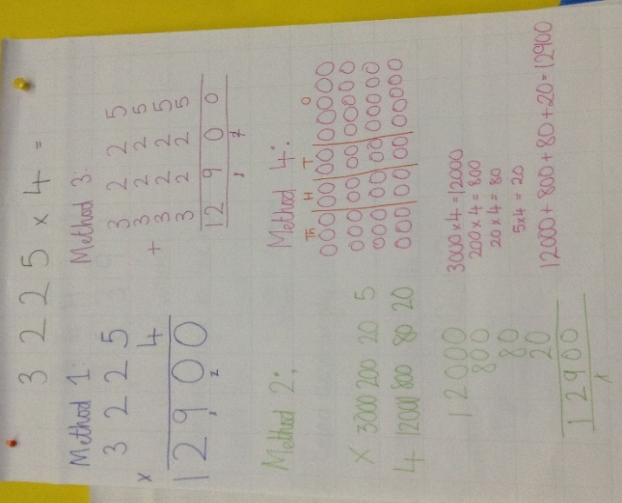

Homework in Year 6
Your child will have received their term overview of spellings. Can you please encourage your child to practice their spellings each week. Spelling tests will be on Thursdays.
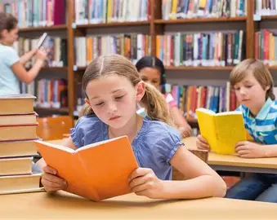
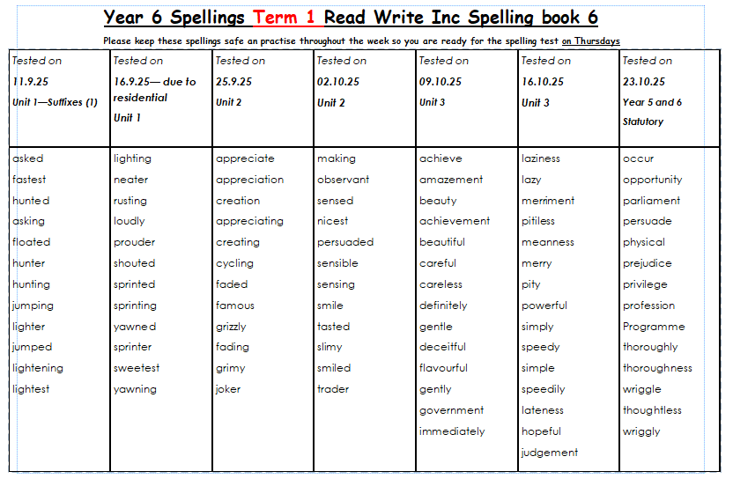
Year 6 children are expected to read for 15-20 minutes per day, 5 days a week. They will need to write a comment relating to what they have read in the yellow reading records.
Online homework – Doodle.
Homework will be set on Doodle on a Thursday; it is due the following Wednesday. The children will be set an assignment in Doodle English, Doodle Maths and Doodle Spell (which will follow the spelling test words above). All children are expected to complete their work to best prepare them for the secondary school expectations.
Other Subjects: During the term we will also be covering programming in Computing using ‘Micro:bits’ to creating a step counter. To find out more: BBC Micro:bit: What's it all about? | National Geographic Kids (natgeokids.com).
In RE will be answering the question – ‘’ Is it better to express your religion in arts and architecture or in charity and generosity?”.
During our PE lessons we will be developing our Tennis and Volleyball skills, including; accuracy and different serves.
For French this term we will look at grammatical elements; including how the ending of words may vary depending on whether they are masculine, feminine or neutral.
In Art the children will be creating street art.

In English our main writing genres will be Narrative
Writing Genre: | Narrative
Work: | Pupils will be considering life in Victorian England and creating a story based on the hardships and challenges of the time.
Main skills covered  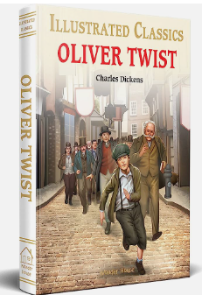 | Narrative has a clear title.  Narrative has an introduction that sets the scene and catches the reader’s interest. It introduces the main character(s), describes the setting or tells of an interesting event using figurative language.  Narrative has a ‘build up’ which introduces the storyline for the main character(s). It drops some clues as to what may happen later building suspense and tension.  Narrative has a ‘dilemma’ which introduces the main problem involving the main character(s) that needs to be fixed  Narrative has a ‘resolution’ that describes how the problem is solved for the main character(s)  Speech has been used and punctuated correctly.  Narrative has an ending which is not ‘Happily ever after’  Paragraphs have been used to demonstrate a change of time and / or place and / or idea  Narrative has range of sentence types including more complex sentences  Narrative contains a large range of punctuation  Narrative contains a variety of sentence openers  Narrative is presented neatly with joined handwriting  High frequency words have been spelt correctly
Ways to help at home: | Read a range of texts that your child can then build up a collection of ideas for their own use when writing narratives.
Spelling: We will be following the year 5 and 6 key words using Spelling Frame to support this: https://spellingframe.co.uk/
Guided Reading: Our guided reading book this term will be Oliver Twist by Charles Dickens. This is a great classic for your children to enjoy, which introduces them to archaic language of Victorian England.

English
- 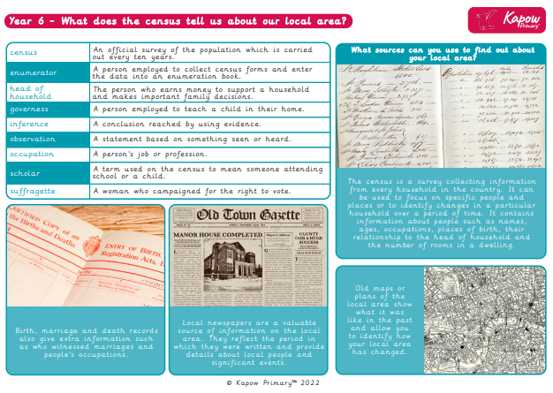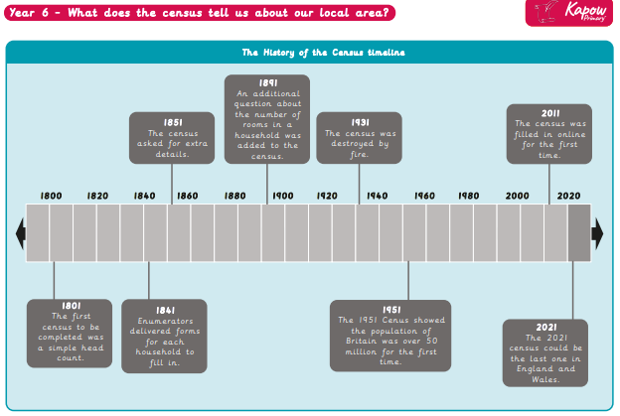Prior Learning
Knowledge Organiser Term 1 – History – Who are we?
- Understanding that history is divided into periods of history e.g. ancient times, middle ages and modern
- Explaining similarities and differences between daily lives of people in the past and today.
- Using a range of sources to construct knowledge of the past.
- Recalling some important people and events.
- Beginning to develop a chronologically secure knowledge of local, British and world history across the periods studied.
- Extracting the appropriate information from a historical source.
- Using dates and terms related to the unit and passing of time e.g. millennium, continuity and ancient.
- Comparing and contrasting different historical sources.

