Decimals, FDP and ratio
- A decimal is a way of writing a number that is not whole.
Decimal numbers are 'in between' numbers. For example, 10.4 is in between the numbers 10 and 11. It is more than 10, but less than 11.
Take care when reading the values of decimal numbers.
4.2 means 4 and 2 tenths.
- FDP stands for Fractions, Decimals and Percentages, which are three different ways of expressing a part of a whole123. They are all equivalent, and we can convert between them. For example, "Half a cake", "0.5 of a metre" and "50% off sale" are all equivalent. Children learn about the equivalence of these in UKS2/3
- Ratio is a way of showing how much of each thing there is compared to another.
It tells us how parts are shared or mixed.
For example, if a recipe uses 2 cups of juice for every 1 cup of water, the ratio is 2 : 1.

Cecil Road Nursery and Primary School
Year 6 Term 3, 2025-2026

This term we will be focusing our learning on decimals, percentages and ratio. Having spent time on fractions, we will now look at the connection between fractions, decimals and percentages. We will then look at ratio, specifically what the ratio symbol means linking this understanding back to our knowledge of fractions and apply reasoning to problem solving questions.
.

Practice of number bonds will really benefit pupils with + and -. A good website to practice these is https://www.topmarks.co.uk/maths-games/hit-the-button If you cluck on number bonds and go to the addition and subtraction within 20 sections..
We will also be starting TTRockstars https://play.ttrockstars.com/auth/school/student/42278 We will be setting 1x, 2x, 3x, 4x, 5x and 10x from here this term.

Mathematics
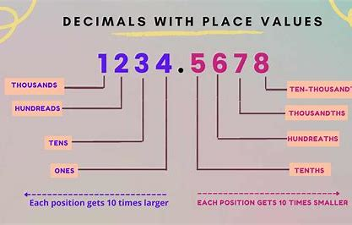

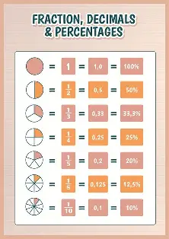
You can support your child at home by encouraging them to learn the key fraction, decimal and percentage equivalents:
1 = 100%
½ = 50% = 0.5
1/3 = 33.3% = 0.33
1/10 = 10% = 0.1
¼ = 25% = 0.25
1/5 = 20% = 0.2
1 / 8 = 12.5% = 0.125

In English our main writing genre will be narrative
Writing Genre: | Narrative
Work: | This term the children will be reading the text – Darwin’s Dragons by Lyndsay Galvin, a wonderful story set in the Galapagos Islands. The children will continue to develop their comprehension skills answering a range of questions.  During English writing lessons, we will be using different stimulus to encourage creative writing. We start by using film clips and then finish the term by looking at picture books.
Main skills covered | - Spelling and grammar  - Story structure and continuity (Does make sense and does it flow?)  - Character and plot analysis. (Are your character’s engaging? Does your problem / resolution work?)  - Creating tension and mood using language  - Develop characters by use of speech  - Figurative language – metaphors, similes,  - personification and more
Ways to help at home: | Discuss the plot of the adventures they like whether it be TV films/ series or books. Talk about the characters and what makes them tick.

Spelling: We continue to follow the Year 5 and 6 key words from our RWI books. Please check on Doodle for the weekly spelling assignment as this forms our spelling test.
English

Knowledge Organiser Term 1 - Animals Including Humans – Year 6

Other Subjects: During the term we will also be completing our webpage creation unit in Computing. In RE will be exploring what means most to Humanists and Christians. During these sessions, we will look at good, bad, forgiveness and fairness. It will also give children a chance to explore Humanism, which they may not have previously studied. During our PE lessons we will be focusing on Basketball and Gymnastics. During these units, the children will engage in activities to improve a range of skills; both physical and social and learn the rules of competitive basketball. Children will also be given the opportunity to improve their health and stamina when engaging in activities for a period. In Art we will be looking at some famous pieces of art and exploring and discussing the narratives they convey using our own experiences to justify our reasons. We will then research and create our own piece that conveys its own narrative.



