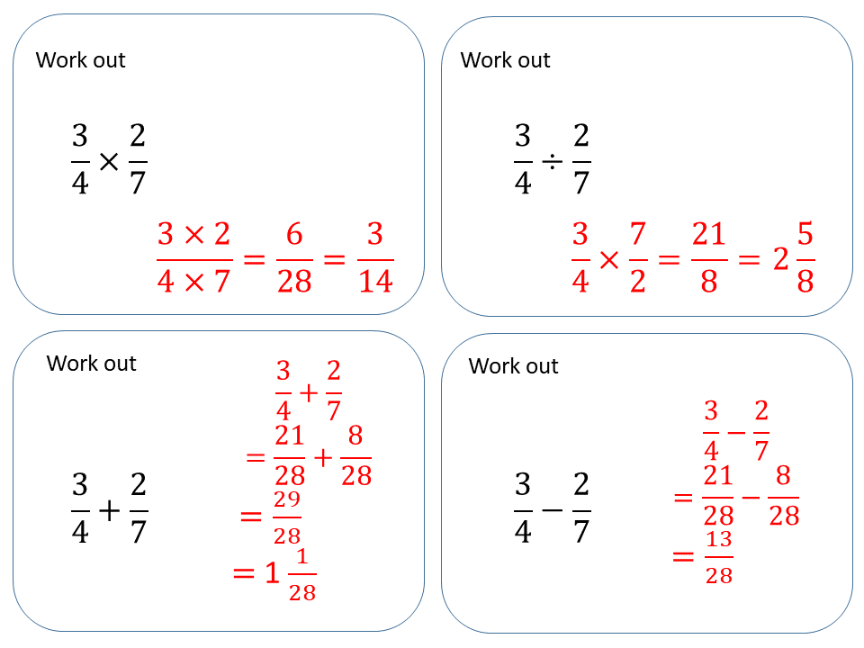
Key Questions…
This unit provides a great opportunity to develop their problem solving and reasoning skills and allows them to make connections between areas in maths. 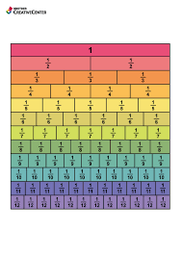
This unit is important because it develops children’s understanding of fractions, moving onto comparing, adding and subtracting unrelated fractions using common denominators (LCM) and formal methods. It encourages problem solving of fraction problems while exploring efficient methods.
Cecil Road Nursery and Primary School
Year 6 Term 2, 2025-2026

This term in maths we will begin by focusing on fractions. Throughout the unit, we will develop our knowledge of the four operations using fractions and then use our fraction knowledge to find fractions of given amounts.
.

Practice of number bonds will really benefit pupils with + and -. A good website to practice these is https://www.topmarks.co.uk/maths-games/hit-the-button If you cluck on number bonds and go to the addition and subtraction within 20 sections..
We will also be starting TTRockstars https://play.ttrockstars.com/auth/school/student/42278 We will be setting 1x, 2x, 3x, 4x, 5x and 10x from here this term.

Mathematics
• How is multiplying fractions by integers similar to addition of fractions? How is it different? • What happens to the denominator when you multiply a fraction by an integer? • Do you find it easier to partition the mixed number first or to convert it to an improper fraction? • Is 2 3 × 7 equal to 7 × 2 3? Why?
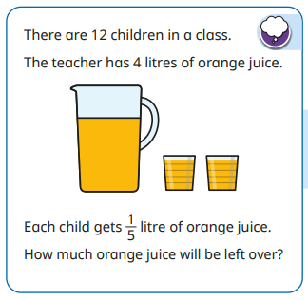

In English this term we will be focusing on narrative.
Writing Genre: | Narrative | Narrative
Work: | Dracula | Kensuke’s Kingdom
Main skills covered | In narratives, describe settings, characters and atmosphere.  Write effectively for a range of purposes and audiences, selecting language that shows good awareness of the reader (e.g. the use of the first person in a diary; direct address in instructions and persuasive writing).  Use a range of devices to build cohesion (e.g. conjunctions, adverbials of time and place, pronouns, synonyms) within and across paragraphs.  Use verb tenses consistently and correctly throughout their writing  Greater depth: Write effectively for a range of purposes and audiences, selecting the appropriate form and drawing independently on what they have read as models for their own writing (e.g. literary language, characterisation, structure). | - In narratives, describe settings, characters and atmosphere.  - Write effectively for a range of purposes and audiences, selecting language that shows good awareness of the reader (e.g. the use of the first person in a diary; direct address in instructions and persuasive writing).  - Use a range of devices to build cohesion (e.g. conjunctions, adverbials of time and place, pronouns, synonyms) within and across paragraphs.  - Use verb tenses consistently and correctly throughout their writing
Ways to help at home: | Read Spooky Stories  Your students can gain inspiration for their own stories by exploring some spooky books. Whether they gain plot, character, or setting ideas, spooky books have a way of capturing the attention of students and helping them become motivated to write their own scary narrative. | Get your child to become a story-teller.  You can help children who struggle with story-telling by letting them know when you’re confused and helping them to include all the important information in the right order. Using pictures or photos can help with this.
Spelling: We continue using Doodle Spell.
Guided Reading: Our guided reading book this term will be Escaping the Giant Wave by Peg Kehret ace to face with a tsunami. We will follow this with Kensuke’s Kingdom by Michael Morpurgo - an award winning text. We will use both books to guide us during some of our English lessons as well.
English

Knowledge Organiser Term 1 - Animals Including 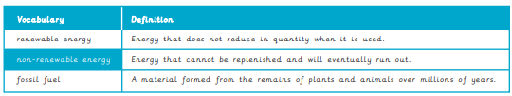Humans – Year 6
Other Subjects: During the term we will also be completing our 3D Modelling unit in Computing. In RE will be answering the question- “What difference does it make to believe in Ahimsa, Grace & Ummah?”. During our PE lessons we will be focusing on Hockey and Netball and how to play safely whilst still incorporating skills such as team work and hand-eye coordination. In French this term we will be looking at: daily routine in other countries, houses, rooms in a house, Christmas: toys from around the world.
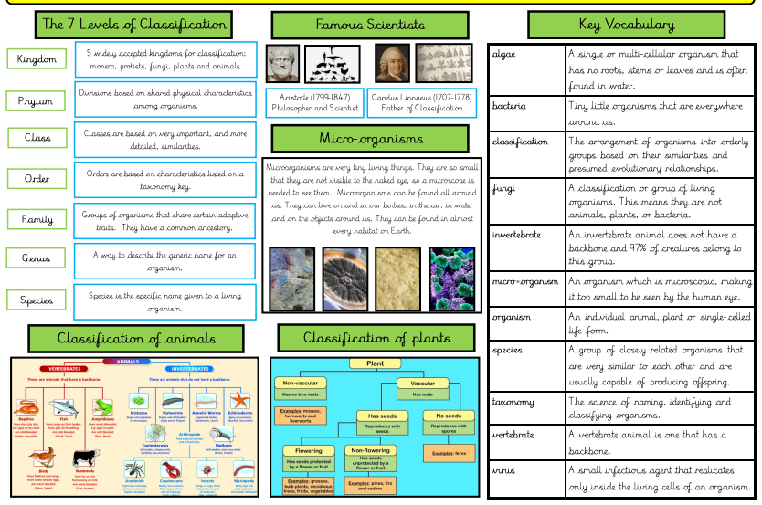
Knowledge Organiser Term 2 – Geography


