Cecil Road Nursery and Primary School.
Year 3, Term 1 2026-27
Mathematics

In mathematics this term, we will be starting with place value and then continuing with addition and subtraction of 2 and 3-digit numbers with regrouping, moving from concrete representations using place value counters and base 10 equipment, onto a more abstract written method.
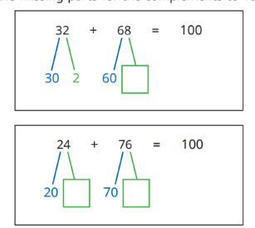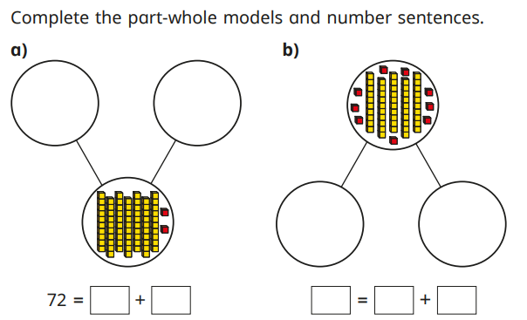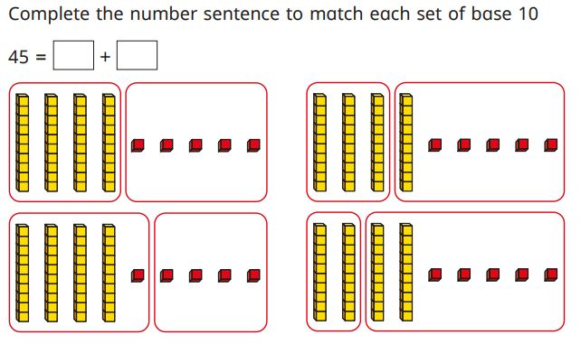

We will also be continuing with TTRockstars https://play.ttrockstars.com/auth/school/student/42278 where children can practise their times tables.

In English our writing genres will be Narrative Stories, and instructions.
Writing Genre: | Narrative Stories | Instructions
Work: | We will begin by studying the story Stone Age Boy and will be using this text to make predictions and then write in character. We will also look at setting and using extended noun phrases. After that we will be completing drama activities involving a mammoth hunt to help imagine what life would have been like for the characters involved. After working on a shared write as a class the pupils will be writing their own stories. | We will be reading the book ‘How to wash a Woolly Mammoth’ and writing a set of instructions on how to wash a Woolly Mammoth.
Main skills covered | - Planning stories with an opening, build-up, problem, resolution and ending  - Describing Settings using adjectives, ENP’s and similes. (The tall, dark mountains reached over us like giants.)  Linking parts of their stories together using fronted adverbials and conjunctions e.g. Within minutes, the chase had begun.. After leaving the camp, they quickly spotted a trail.. | - Using imperative verbs as part of our instruction writing, e.g. fill, add, wash.  - Use prepositions to show position  - Planning, writing, editing and evaluating our work.
Ways to help at home: | When reading at home discuss the settings in the books your child read. Ask why the writer has chosen to use certain words or how have they created a scary or safe setting. | Practise following and giving instructions for simple tasks such as brushing teeth.
Spelling: This term we will be covering: adding the suffixes -ful -less -ment and homophones.
Guided Reading: Our guided reading book this term will be Stone Age Boy by Satoshi Kitamura. When on a walk, a modern young boy trips, falls and finds himself in the Stone Age. He makes friends with a girl his age, who shows him Stone Age life. We will be making predictions about what we think will happen, summarising key events and answering retrieval questions about the characters, plot and setting. With home reads please also ask your child lots of questions about what they think is going to happen, ask them to sum up what they have read and also ask questions about the characters and setting.
Other Subjects: During the term in Computing we will be using desktop publishing. In music we will be starting our weekly Recorder lessons taught by Mr Patterson from Kent Music School. In RE will be answering the question – ‘What does it mean to be a Christian in Britain today?’
PE will be every Tuesday and Thursday so please make sure kits are in school on these days. This term we are beginning with ball skills and fundamentals.

English

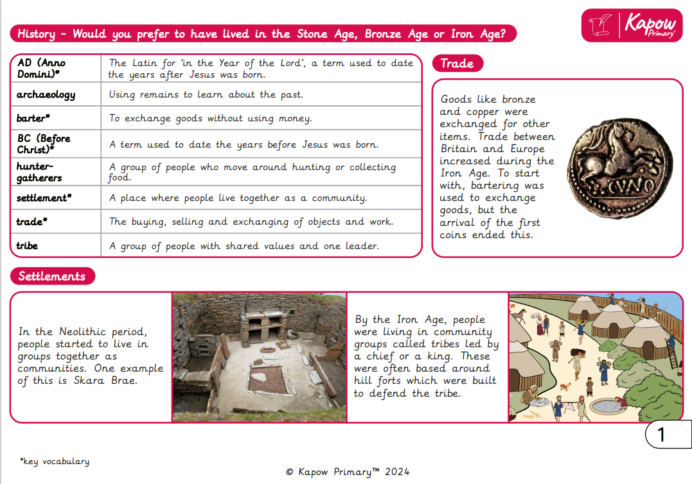
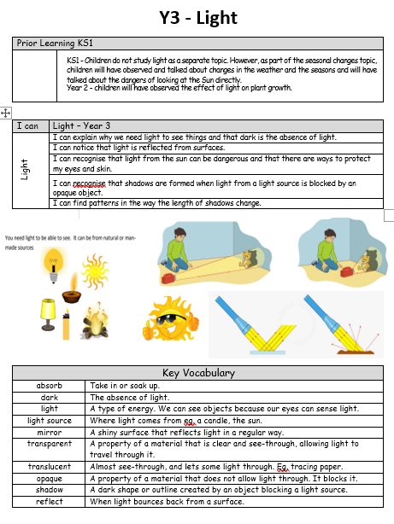

Life Skills

Life Skills gives the children the opportunity to develop the knowledge, confidence and independence needed to manage everyday situations safely and responsibly. They will practice and apply these skills during the school day and become increasingly capable of making decisions, solving problems and taking responsibility for themselves.

Each term the children will complete a unit covering one of the following strands:  - Personal independence and responsibility  - Personal safety  - Health and hygiene  - Communicating with others (manners and social awareness)  - Community and Navigation  - Employment awareness (preparing for future years) | Term 1  During term 1, we will be covering aspects of Personal independence and responsibility including:  Knowing what clothes to wear or bring for the right weather  The importance of labelling my clothes and my bag  Packing my school bag and my P.E kit ready for the lesson  Using a knife and fork appropriately



