
Cecil Road Primary & Nursery School
Cecil Road, Gravesend
Kent. DA11 7BT
Tel: (01474) 534544
office@cecilroad.co.uk
Headteacher: Mrs C. Old

Dear Parents/ Carers,
It has been lovely to meet and get to know all our new children.
Water Bottles
The children must bring a water bottle in every day. This bottle must contain water, this is in addition to a drink in a packed lunch.

Packed Lunch
Please remember we are a NUT FREE, healthy school. Therefore, lunch boxes must not contain any food containing nut or sweets.

Our topic this term is ‘All about Me’ – Each day, we will discuss new emotions or potential worries: Friends, Family, Things we like to do, Places we like to go. This topic allows us to get to know the children well and gives them the opportunity to talk about things they like and dislike, their families and things they enjoy doing.

If your child has any allergies or dietary requirements, please ensure this is all on Arbor as soon as possible.
If your child is to be collected by someone different to usual, please message us on Dojo!
Important dates
- Wednesday 2nd September – Children are in school from 8.40 till 11
- Thursday 3rd September – Children are in school from 8.40 till 1.30 (Children can bring a packed lunch or order a school dinner by 8am)
- Friday 4th September – Children are in school from 8.40am till 3.30pm
- Tuesday 15th September – Year R and 1 Phonics meeting at 2.45
- Thursday 24th September Parent Meeting about Handwriting 3pm
- Wednesday 30th September – Individual/Sibling Photos
- Friday 2nd October – Parent Maths Workshop
- Wednesday 7th October – Harvest Festival Rosen 9 – 9.30 and Donaldson 3 – 3.30
- Wednesday 14th and Thursday 15th October - Parents Evening
- Friday 16th October Children wear Red – Show racism the red card
- Tuesday 20th October – Colour Run
- Wednesday 21st October – Last day of Term

Reading Books- Will be sent out later in the term!
This term in the following areas we are learning to…

Personal, Social and Emotional Development

- To describe and show friendly behaviour.
- To begin taking turns with their friends.
- Begin to develop friendships with other children within the setting.
- Select and use activities and resources, with help when needed from an adult
- Express their feelings and manage their own needs.
- Be confident to try new activities and show independence
- Understanding the importance of healthy food choices.


Communication and Language
- To know about others.
- To know familiar songs.
- To describe different story and non-fiction texts.
- Listen to simple stories and understand what is happening with the help of the pictures.
- Understand and act on longer sentences
- Engage in story times.
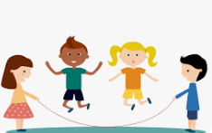
Physical Development
- Gross motor skills: Negotiate space and obstacles safely, with consideration for themselves and others; Move energetically, such as running, jumping, dancing.
- Fine motor Skills: Experience activities to develop finger muscle strength such as dough disco, clever fingers.

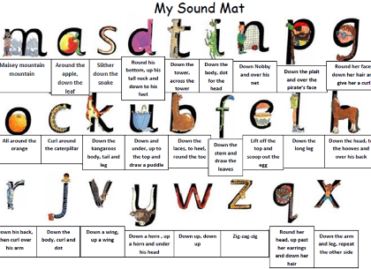
Literacy / phonics
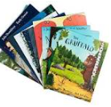
- Read first 16 Set 1 sounds Learn to blend: Word Time 1.1 to 1.3 Spell using Fred Fingers
- Shows awareness of rhyme and alliteration.
- Joins in with repeated refrains and anticipates key events and phrases in rhymes and stories.
- Interest in illustrations and print in books and print in the environment.
- To copy letter shapes which are familiar to them e.g. from their name.
- To give meaning to the marks they make as they write.
- To copy taught shapes and letters.
- To write the initial sounds in words.
- Begin to form lower case letters correctly
- Emergent writing opportunities in play e.g. lists, cards

Maths
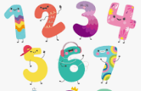
- 1:1 counting.
- Recognising and ordering numbers to 10.
- Formation of written numbers.
- Subitising.
- Counting groups of objects.
- 2D Shapes
- Pattern.


Understanding the World
Key focus points this term:
- People, Culture and Communities
- UTW: The Natural World
- Ourselves

- To know the names of body parts.
- To identify and sort healthy/unhealthy foods.
- To identify and group a range of fruits and vegetables.
- Comment on images of familiar situations in the past.
- Talk about members of their immediate family and community.
- Name and describe people who are familiar to them.
- Recognise some similarities and differences between religions.
- Explore the natural world around them.
- Being aware of changes that happen throughout the year (e.g. seasons, nature).
- Recognising significant dates for them (birthday).
- Beginning to use common words and phrases for the passage of time, even if using inaccurately (e.g. yesterday, today, tomorrow, last week, “when I was in nursery…”
- Making simple observations about the past from photographs and images.
Expressive Arts and Design


- Name simple instruments
- Investigate marks and patterns when drawing.
- Identify similarities and difference between
- drawing tools.
- Investigate how to make large and small
- movements with control when drawing.
- Practise looking carefully when drawing
- Combine materials when drawing.
Here is to a happy and successful first term at school!
Clothing
If you haven’t already, please ensure all items of your child’s clothing/ belongings are named. If you know that your child is prone to accidents, please send a change of clothing in their PE bag.

Life Skills
I can put my shoes on the right feet
I can use a knife and fork
I can get changed for PE
I can put something in my bag and zip it up

Please don’t forget to sign up to our class Dojo!
Thank you so much for your support,
The Reception T

