English
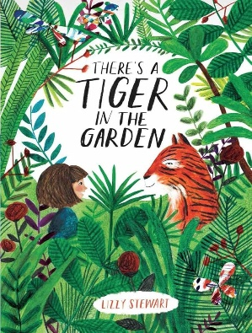
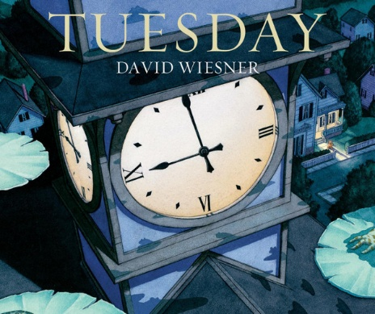
In English, we will be basing our writing around two picture books ‘There’s a Tiger in the garden’ by Lizzy Stewart and ‘Tuesday’ by David Weisner. We will also be exploring exciting pictures for writing stimuluses. The purpose of this term is to secure our sentence structure writing, but to also begin writing more descriptively. The children will be practicing their use of capital letters, full stops and fingers space within a sentence. They will then be introduced to describing words to make their writing more interesting.
These skills will support them in working towards writing a short story of their own about the wordless picture book we will be using called ‘Tuesday’. It is a funny story about frogs being able to fly through the night. we hope it will inspire their creative writing minds!
For Guided Reading, we will be having daily reading lessons, alongside the Talk through Stories programme. Each week we will be reading a different story and practising our reading skills. Guided Reading lessons focus on 8 main reading skills. These are: vocabulary, reading fluency, retrieval (remembering information from the text), inference (discussing and understanding what has happened in the text and why), prediction, summarising, making connections (linking it to other things they know/have read) and author’s choice (identifying how the author’s choices effect the reader/text). We will be exploring various fairy tales to support these reading lessons.
To support your child’s reading and writing development, at home you can:
-listen to your children read often at home (the more children read, the more they are exposed to the correct structure of sentences to support their writing and the more vocabulary they will pick up).
-show children the importance of reading (take trips to the library, talk to them about what you like to read, enjoy books together, listen to audiobooks).
As it is the start of the year, some children will continue reading their RWInc books, depending on the progress made in year 1. For the other children, they will now be joining the Accelerated Reader program and will be taking our Star Reading Assessment to find out what books levels they will be reading from. The children are given a ZPD range (Zone of Proximal Development) which is in number form and is based on various reading skills. They will be able to choose books from the given range until we reassess, or the class teacher feels they need to move to a more suited range.

Spellings
In year 2, we continue to follow the RWInc program, by embedding the sounds previously set and introducing the children to new spelling rules. We will also be revising the year 1 common exception words (red words).
The spelling rules we will cover this term are:
Unit 1: The or sound spelt a before l and ll
Unit 2: Soft c
Unit 3: Adding the suffix –y
Unit 4: Adding the suffix –y (2)
Here are the spelling lists we will be exploring:

2A Unit 1 word list | 2A Unit 2 word list | 2A Unit 3 word list | 2A Unit 4 word list | Year 1 Common Exception Words
all  already  altogether  almost  also  always  ball  chalk  hall  call  fall  small  stalk  wall  talk  walk | cell  circus  concentrate  certain  city  concert  cycle  except  face  excellent  exercise  fancy  icy  notice  police  mice  pencil  price  race  rice | boggy  foggy  muddy  dotty  funny  nutty  runny  sloppy  sunny  saggy  spotty  yummy | bony  breezy  cheesy  crazy  curvy  greasy  lazy  mousy  shiny  simply  smoky  snappy  spicy  spiky  sunny  wavy  wheezy  whiny | the  a  do  to  today  of  said  says  are  were  was  is | his  has  I  you  your  they  be  he  me  she  we
Please do explore these words together with your children!
Mathematics
In Maths, we will be consolidating our Year 1 place value work. Then, moving on to developing our knowledge of whole numbers – saying and understanding what each digit represents in a 2-digit whole number. We will also partition a 2-digit number in different ways, using a variety of resources to demonstrate of understanding.

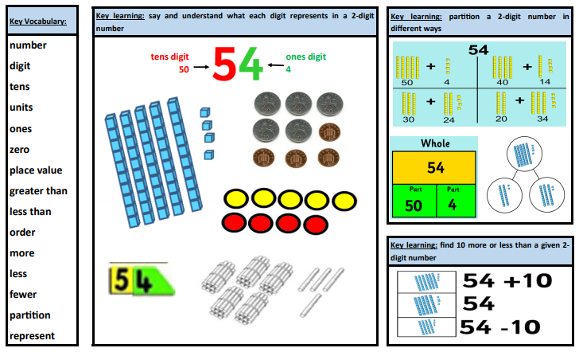
We will also start recapping our Year 1 knowledge and understanding of addition and subtraction.
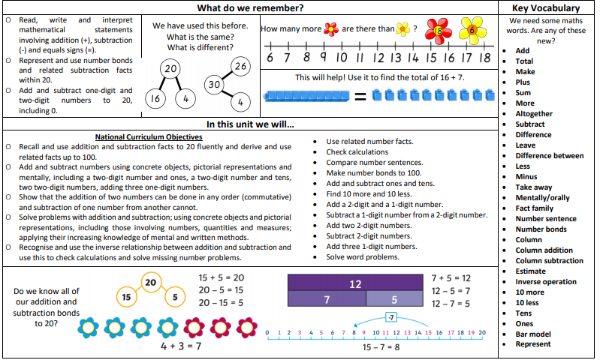
History will be the main theme leading other curriculum learning during the term.
How was school different in the past?

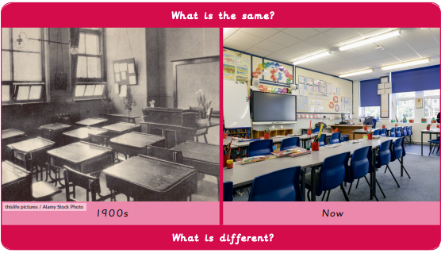
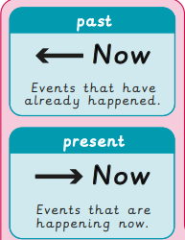
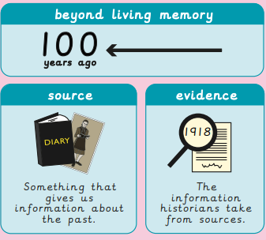
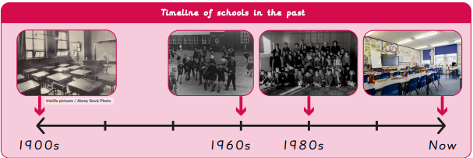
Science
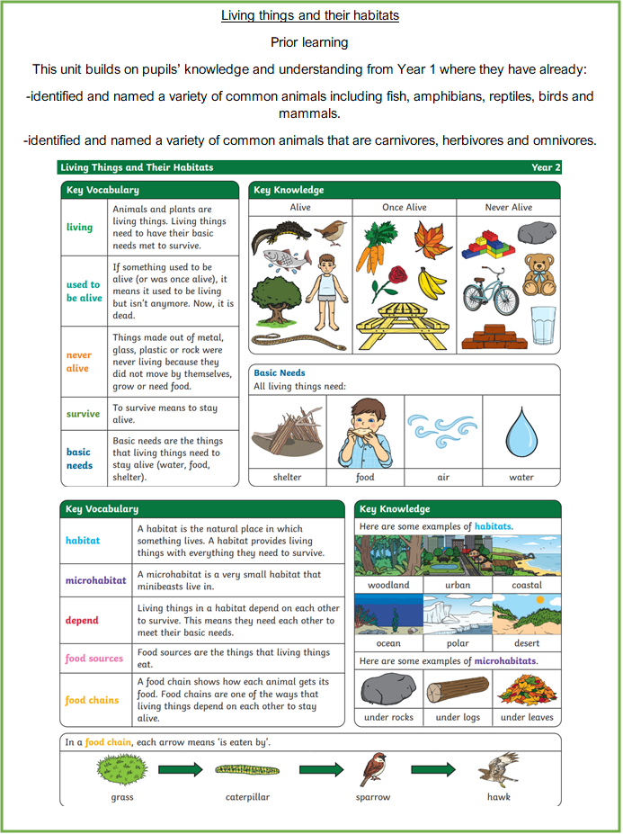
RE
How should we care for others and the world, and why does it matter?
Whilst exploring this enquiry question, children will learn in depth about the Christian and Jewish ways of life and beliefs. They will listen to different religious stories and discuss its meanings and teachings.
PSHE
What helps us grow and stay healthy?
In this unit, children will understand:
-That different things help their bodies healthy.
-That eating and drinking too much sugar can affect their health.
-How to be physically active and how much rest and sleep they should have every day.
-That there are different ways to learn and play; how to know when to take a break.
-How sunshine helps our bodies.
Computing
Computer systems and networks – Information Technology around us.
Learns will develop their understanding of what Information Technology (IT) is and will begin to identify examples. They will discuss where they have seen IT in school and beyond, in settings such as shops, hospitals, and libraries. Learners will then investigate how IT improves our world, and they will learn about the importance of using IT responsibly.
Gymnastics
INSIDE GYMNASTICS
In this unit pupils learn, explore and develop basic gymnastic actions on the floor and using apparatus. They develop gymnastic skills of jumping, rolling, balancing and travelling individually and in combination to create short sequences and movement phrases.
Team games
OUTSIDE TUESDAYS
In this unit pupils develop their teamwork skills. They develop key skills of communication and problem solving. They learn to discuss, plan and reflect on ideas and strategies. They lead a partner whilst considering safety. Pupils have the opportunity to show honesty and fair play.

Craft and design: Map it out
This unit focuses on teaching children to explore and create maps through various art forms, including drawing, felt making, printmaking, and designing stained glass. The lessons aim to develop skills in sorting, designing, and evaluating art, encouraging students to present and discuss their creations in a class gallery setting. Use this unit hub to inform your medium-term plan and to navigate to related resources.

Music
Mars by Holst
Listening to music and creating rocket music.

Life skills
This term we will be focusing on developing the children’s Personal Independence and responsibility. We will be supporting them in tying their shoelaces and using a knife and fork correctly.

