Special Educational Needs and Disabilities (SEND) Information Report
Cecil Road Primary and Nursery School

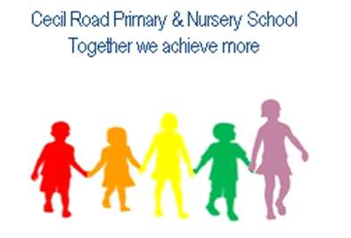

Inclusion Team
SEND Governor: Mr Jake Fisher
SENCO: Miss Laura Southgate
SEN Assistant: Miss Jemma Relph
Contact No. 01474 534544
Inclusion Team:
inclusion@cecilroad.co.uk

Approved by: | Governing Body and Headteacher | Date: October 2025
Last reviewed on: | October 2023, October 2024, October 2025, February 2026
Next review due by: | October 2026

Contents
1. What types of SEND does the school provide for?
2. Which staff will support my child?
3. What should I do if I think my child has SEND?
4. What happens if the school identifies a need?
5. How will the school measure my child’s progress?
6. How will I be involved in decisions made about my child’s education?
7. How will my child be involved in decisions made about their education?
8. How will the school adapt its teaching for my child?
9. How will the school evaluate whether the support in place is helping my child?
10. How will the school ensure my child has appropriate resources?
11. How will the school make sure my child is included in activities alongside pupils who don’t have SEND?
12. How does the school make sure the admissions process is fair for pupils with SEN or a disability?
13. How does the school support pupils with disabilities?
14. How will the school support my child’s mental health and emotional and social development?
15. What support is in place for looked-after and previously looked-after children with SEN?
16. What support will be available for my child as they transition between classes or settings or in preparing for adulthood?
17. What support is available for me and my family? (Local Offer)
18. What should I do if I have a complaint about my child’s SEND support?
19. Supporting Documents…………………………………………………………………………………………………………….
20. Glossary

Dear parents and carers,
The aim of this Information Report is to explain how we implement our SEND policy. In other words, we want to show you how SEND support works in our school.
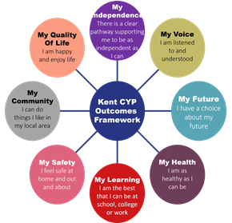
As educational professionals, we are all working towards the ultimate goal of growing independent young people as they prepare for adulthood. All provision and support we provide is working towards achieving the Kent Children and Young People (CYP) Outcomes Framework:

If you want to know more about our arrangements for SEND, read our SEND policy alongside this Information Report.
You can find our SEND policy on our website https://www.cecilroad.co.uk
Note: If there are any terms we’ve used in this information report that you’re unsure of, you can look them up in the Glossary at the end of the report.

1. What types of SEND does the school provide for?
Our school provides for pupils with the following needs (as outlined in the SEND Code of Practice 2015):

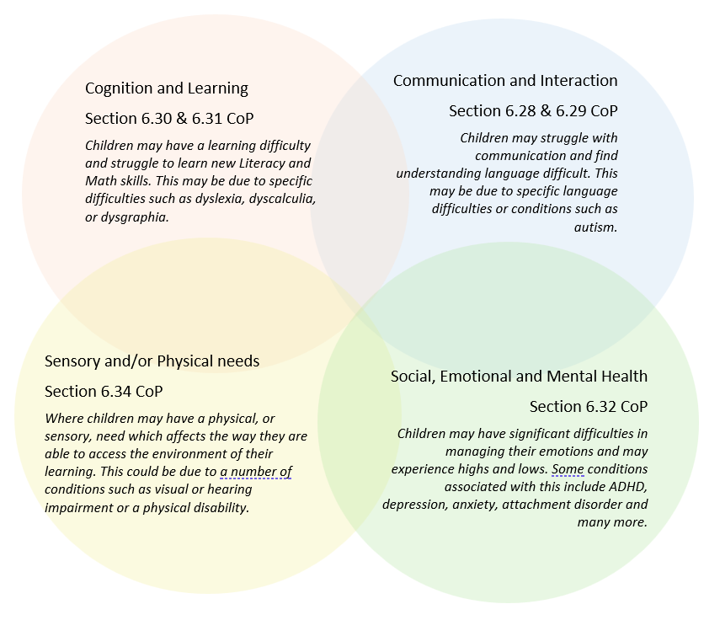

Often you will find that children’s needs overlap and are rarely confined to one area of need, which is why it is important to gain a wholistic overview of your child.
More information about the Areas of Need can be found in the Special educational needs and disability code of practice: 0 to 25 years (link below).
SEND_Code_of_Practice_January_2015.pdf (publishing.service.gov.uk)


2. Which staff will support my child, and what are their key responsibilities?

At Cecil Road Primary and Nursery School, all staff are considered responsible for supporting the needs of pupils with SEND. Our staff are committed to regular, high-quality training to ensure that they have the knowledge and skills to better meet a wide range of pupil needs.
Below outlines key staff who will be supporting your child. Please note that this list is not exhaustive.
Our Special Educational Needs Co-ordinator, or SENCO
The named SENCO is Laura Southgate.
She is a qualified teacher and a member of the Senior Leadership Team. Laura has achieved the National Award in Special Educational Needs Co-ordination.
As SENCo, Laura focuses on the SEN support across the whole school, including the nursery.
In her role as SENCo, she:
- Works with the Headteacher and SEN governor to determine the strategic development of the SEN policy and provision in the school.
- Has day-to-day responsibility for the operation of this SEN policy and the co-ordination of specific provision made to support individual pupils with SEN, including those who have EHC plans.
- Provides professional guidance to colleagues and work with staff, parents, and other agencies to ensure that pupils with SEN receive appropriate support and high-quality teaching.
- Advises on the graduated approach to providing SEN support.
- Advises on the deployment of the school’s delegated budget and other resources to meet pupils’ needs effectively.
- Is the point of contact for external agencies, especially the local authority, and its support services.
- Liaises with potential future providers of education to ensure pupils and their parents are informed about options and a smooth transition is planned and facilitated.
- Works with the Headteacher and governing board to ensure that the school meets its responsibilities under the Equality Act 2010 with regard to reasonable adjustments and access arrangements.
- Ensures the school keeps the records of all pupils with SEN up to date.

Class teachers
All of our teachers receive in-house SEN training, and are supported by the SENCO to meet the needs of pupils who have SEN.
Each class teacher is responsible for:
- The progress and development of every pupil in their class.
- Working closely with any teaching assistants or specialist staff to plan and assess the impact of support and interventions and how they can be linked to classroom teaching.
- Working with the SENCO to review each pupil’s progress and development and to decide on any changes to provision.
- Ensuring they follow this SEND policy.
Teaching assistants (TAs)
We have a number of TAs, including higher-level teaching assistants (HLTAs) who are trained to deliver SEN provision.
We have teaching assistants who are trained to deliver interventions such as; Sensory Circuits, Colourful Semantics, Precision Teaching, Comic Strip Conversations and Social Stories, Memory Magic and Intensive Interactions.
In the last academic year, TAs have been trained in Colourful Semantics, ADHD, Positive Behaviour Management and de-escalation, Making Effective Use of Visuals, Sensory Processing Differences, Gestalt Language Processing (GLP) and Profound Hearing Loss.

External agencies
Sometimes we need extra help to offer our pupils the support that they need. Whenever necessary we will work with external support services to meet the needs of our pupils with SEND and to support their families. These may include:

- Child and adolescent mental health services (CAMHS)
- Emotional Well-Being Practitioners
- GPs or paediatricians
- NELFT practitioners
- Occupational therapists


- Voluntary sector organisations
- Physiotherapists
- Safeguarding services
- School nurses
- SEND Inclusion Advisor (SIA)
- Specialist Teaching and Learning Service

- Speech and language therapists

3. What should I do if I think my child has SEND?

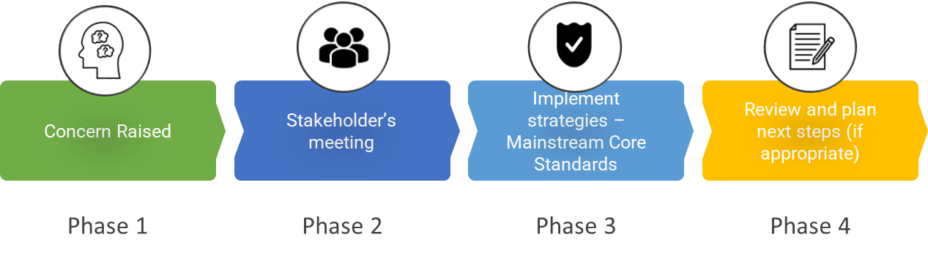

Phase 1 | If you think your child might have SEND, the first person you should tell is your child’s teacher. You can contact the school office via email office@cecilroad.co.uk or via telephone 01474 534544 to arrange an appointment with your child’s class teacher.  They will pass the message on to our SENCo, Laura Southgate, who will be in touch to discuss your concerns.
Phase 2 | We will meet with you to discuss your concerns and try to get a better understanding of what your child’s strengths and difficulties are. Together we will decide what outcomes to seek for your child and agree on next steps. We will make a note of what’s been discussed and add this to your child’s record.
Phase 3 | We will implement the agreed strategies and monitor these over an agreed period of time. These are likely to be universal strategies set out in the mainstream core standards. A copy of this can be found here: Mainstream Core Standards Kent .  This will initiate the ‘Graduated Approach’ where support will be continually reviewed. See next page for more details.
Phase 4 | If we decide that your child needs SEND support, we will formally notify you and your child will be added to the school’s SEND register. They will receive additional support and this will be reviewed using the assess, plan, do, review model.

4. What happens if the school identifies a need?
The same process is followed if a concern is raised by the school.

All our class teachers are responsible for the monitoring of all pupils who have been identified as having SEND. They also review those who are not making the expected level of progress in their schoolwork or socially.
If the teacher notices that a pupil is having difficulties, they try to find out if the pupil has any gaps in their learning. If they can find a gap, the school will provide appropriate support. Pupils who don’t have SEND usually make progress quickly once the gap in their learning has been filled.
If the pupil is still finding it difficult to make the expected progress, the teacher will talk to the SENCO and will contact you to discuss the possibility that your child has SEND, and the school will follow the graduated approach (see previous page).

5. How will the school measure my child’s progress?

At Cecil Road, we follow the ‘graduated approach’ to meeting your child’s SEND needs.
The graduated approach is a 4-part cycle of assess, plan, do, review.
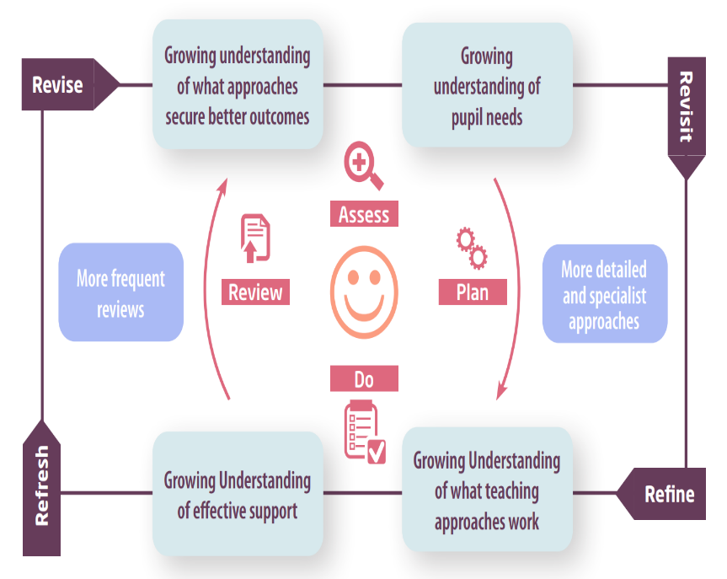

Assess | If your child is not making the expected level of progress, we will make an assessment to find out what strengths and difficulties your child has. We will ask for you and your child’s input, as well as getting help from external professionals where necessary.
Plan | In discussion with you and your child, we will decide what outcomes we are hoping to achieve. We will make a plan of the support we will offer your child to help them meet those outcomes. We will make a record of this and share it with you and all relevant school staff.
Do | We will put our plan into practice.  The class teacher, with the support of the SENCO, will be responsible for working with your child on a daily basis, and making sure the support we put in place is having the impact we intended.
Review | We will assess how well the support we put in place helped the pupil to meet the outcomes we set. We will use our improved understanding of your child’s needs to improve the support we offer; this may mean the Plan, Assess, Do, Review cycle continues.

6. How will I be involved in decisions made about my child’s education?

Once a year, we provide written reports on your child's progress. In addition to this, all parents of pupils at Cecil Road Primary and Nursery School are invited to discuss the progress of their child on three occasions each year.
A member of staff, who knows your child well, will meet you, to:
- Set clear outcomes for your child’s progress
- Review progress towards those outcomes
- Discuss the support we will put in place to help your child make that progress
- Identify what we will do, what we will ask you to do, and what we will ask your child to do

The SENCO may also attend these meetings to provide extra support.
We know that you’re the expert when it comes to your child’s needs and aspirations. So, we want to make sure you have a full understanding of how we’re trying to meet your child’s needs, so that you can provide insight into what you think would work best for your child.
We also want to hear from you as much as possible so that we can build a better picture of how the SEND support we are providing is impacting your child outside of school.
If your child’s needs or aspirations change at any time, please let us know right away so we can keep our provision as relevant as possible.
If you have concerns that arise between these meetings, please contact the school office, office@cecilroad.co.uk or 01474 534544, to arrange a meeting with your child’s class teacher or the SENCo.

7. How will my child be involved in decisions made about their education?

The level of involvement will depend on your child’s age and individual needs. We recognise that no two pupils are the same, so we will decide on a case-by-case basis, with your input.

We may seek your child’s views by asking them to:
- Attend meetings to discuss their progress and outcomes
- Prepare a written statement, video, voice recording or drawing
- Discuss their views with a member of staff who can act as a representative during the meeting
- Complete a survey



8. How will the school adapt its teaching for my child?

Teachers are responsible and accountable for the progress and development of all the pupils in their class.
High-quality teaching is our first step in responding to your child’s needs. We will make sure that your child has access to a broad and balanced curriculum in every year they are at our school.
We will adapt our approaches to how we teach to suit the way the pupil works best. There is no 'one size fits all’ approach to adapting the curriculum, we work on a case-by case basis to make sure the adaptations we make are meaningful to your child and are guided by the Mainstream Core Standards, in the first instance.

These adaptations may include:
- Adapting our approaches, for example, giving longer processing times, pre-teaching of key vocabulary, breaking instructions down one step at a time or reading instructions aloud.

- Adapting our resources and staffing

- Using recommended aids, such as laptops, coloured overlays, visual timetables, larger fonts.

- Teaching assistants or support staff will support pupils appropriately depending on their presentation of need

- Scaffolding lesson materials

We may also provide the following interventions:
Communication and Interaction
Intervention | Year Groups | Description | Intended Outcomes
Language Link | Year R – Year 2 | Language link groups based on specific needs. | Pupils will develop understanding and skills in selected areas.
Junior Language Link | Year 3 – Year 6 | Language link groups based on specific needs. | Pupils will develop understanding and skills in selected areas.
Speech Link | Year R – Year 6 | Pupils will complete 1:1 work based on speech sounds. | Pupils will develop their speech sounds and become more fluent verbal communicators.
SALT Plan | Nursery – Year 6 | Pupils will complete an assessment with a SALT and will then complete SALT programmes with a Trained TA. | Pupils will develop understanding and skills in selected areas.
Lego Therapy | Year R – Year 6 | Pupils work in groups of 3 to have distinct role to build a Lego model collaboratively and develop communication skills. | Pupils will confidently participate in the 3 different roles and communicate effectively to others within the group.
Attention Autism | Nursery – Year 4 | Work with children in a small group or 1:1. | Pupils will develop their attention skills, as well as developing natural and spontaneous communication skills.
Pre-teaching Vocabulary Group | Year R – Year 6 | Group/1:1 intervention based on developing vocabulary – pre teaching vocab. | Pupils will develop their knowledge of topic vocabulary/key vocabulary and be confident with words and their meanings in context.
Story builders | Year 1- Year 2 | A creative intervention that uses drama activities and story-telling to support children to develop their communication, confidence and well-being. | For pupils to show improvements in their speaking and listening and their understanding of words. For children to develop their confidence with communicating with others.

Cognition and Learning
Intervention | Year Groups | Description | Intended Outcomes
RWI 1:1 | Year R – Year 4 | A five minute, daily activity to enable learners to recap and consolidate their phonics, working one-to-one with a key adult. | Pupils will be able to recall sounds and use these to read and spell words.
RWI small group | Year 1 – Year 3 | A literacy program that uses small groups to consolidate phonics learning. | Pupils will be able to recall sounds and use these to read and spell words.
Fresh Start | Year 3 – Year 4 | Pupils learn new letter-sounds and review previous sounds and words. They apply what they’ve been taught by reading words containing the sounds they know. Spelling is practiced as well as comprehension. | Pupils will gain confidence with reading, writing, spelling and comprehension.
1:1 reading | Year R – Year 6 | Staff to read with pupils and to help with comprehension skills. | Pupils to gain confidence with reading and comprehension skills.
Precision teaching HFW | Year 1 – Year 6 | Daily fluency practice | Pupils to read and write HFW words.
Precision teaching number | Year 1 – Year 6 | Daily fluency practice for reading and saying numbers/bonds. | Pupils will be able to read and say with increasing speed and accuracy.
Neli | Year R – Year 1 | improve children's language and early literacy skills. 3 times a week for 20 weeks. | Pupils will improve oral language skills.
Early Talk Boost | Nursery | Supports children who are just below expected in their Communication and Language development to boost their speaking and listening skills. | Pupils gain confidence in their language and communication skills.
Memory Magic | Year 1 – Year 5 | Children complete activities that are designed to develop their working memory skills. | Pupils will develop their auditory/visual memory skills.
Immersive Reader on Laptops | Year 3 – Year 6 | Supports children with recording their ideas and reading large pieces of text by having it read aloud to them. | Pupils will be able to share and record their ideas through alternative recording methods.
Lexia | Year 2 – Year 6 | Lexia is a computer program that gives pupils independent practice in basic reading skills. | To boost the children in their basic reading skills and hopefully get them to expected.
Colourful semantics | Year 1 – Year 6 | A visual approach to Literacy that is designed to help children develop their language skills by using colour to help them understand how words are linked in sentences. | Pupils will develop their language and communication skills; expanding their vocabulary, enhancing their understanding of sentence structure and grammar and improving their storytelling skills.

Social, Emotional and Mental Health
Intervention | Year Groups | Description | Intended Outcomes
Zones of regulation | Nursery – Year 6 | Programme to develop emotional awareness and emotional regulation. | Pupils will understand different emotions and develop strategies to manage their emotional regulation.
EWP – Emotional Well-Being Practitioner | Year R – Year 6 | Individual support for children.
Draw and Talk Therapy | Year 1 – Year 6 | An attachment-based therapeutic intervention which allows children to discover and communicate emotions through drawing. | Individuals will be able to express their feelings, using a non-directed method, such as drawing.

Physical and Sensory
Intervention | Year Groups | Description | Intended Outcomes
Sensory Circuits | Year R – Year 6 | Alerting, organising and calming activities using all senses | Children will be calm and ready to learn.
Beam | Year R | A programme of exercises to develop children’s core and gross motor strength and movements. | Children to develop their core strength which will support writing and gross motor skills
Sensory breaks | Year R – Year 6 | Children to have a break from learning when needed.  Time is given for calming, organising and alerting | Children to be regulated and ready to learn.
TheraPutty | Year R – Year 6 | Children complete simple exercises with the TheraPutty to strengthen the muscles in their hands used for writing, drawing and cutting. | Increased hand dexterity and fine motor control.
Fizzy- Body Awareness | Year R – Year 6 | An activity programme designed to support children with their gross motor movements and their co-ordination and balance. | An increase in core strength control and improved co-ordination with gross motor movements.
Fizzy Balance | Year R – Year 6 | An activity programme designed to support children with their gross motor movements and their co-ordination and balance. | An increase in core strength and balance control and improved co-ordination with gross motor movements.
Fizzy Ball Skills | Year R – Year 6 | An activity programme designed to support children with their gross motor movements and their co-ordination and balance. | An increase in core strength and balance control and improved co-ordination with gross motor movements.
Fizzy Clever Hands | Year R – Year 6 | An activity programme designed to develop fine motor skills. | Increased hand dexterity and fine motor control.  Increased control when using pens, pencils and scissors.

These interventions are part of our contribution to Kent County Council’s local offer.

9. How will the school evaluate whether the support in place is helping my child?

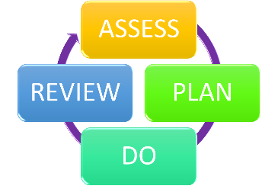
At Cecil Road, we evaluate the effectiveness of provision for your child by:
- Reviewing their progress towards their goals each term
- Reviewing the impact of interventions after 6-12 weeks
- Using pupil questionnaires
- Monitoring by the SENCO
- Using provision maps to measure progress
- Holding an annual review (if they have an education, health and care plan) *
* For pupils with an Education, Health and Care Plan (EHCP), there will be an Annual Review of the provision made for the child. Parents, teachers and any specialist working with the child are invited to attend the meeting. Together we will evaluate the child’s targets and consider the effectiveness of the provision.

10. How will the school ensure my child has appropriate resources?

It may be that your child’s needs mean we need to provide additional resources such as:
- Additional resources to support their learning
- Adaptations to in class support
- Further training for our staff
- External specialist expertise
Where appropriate, we will consult with external agencies to get recommendations on what will best help your child access their learning and use our best endeavours to ensure these are supplied.

11. How will the school make sure my child is included in activities alongside pupils who don’t have SEND?


The expectation is that all schools provide an inclusive provision for all pupils. It may be necessary for some pupils to receive interventions in addition to a broad and balanced curriculum.
All of our extra-curricular activities and school visits are available to all our pupils, including our before and after-school clubs.
All pupils are encouraged to go on our school trips, and visits.
All pupils are encouraged to take part in sports day/school plays/special workshops.
No pupil is ever excluded from taking part in these activities because of their SEN or disability and we will make whatever reasonable adjustments are needed to make sure that they can be included.

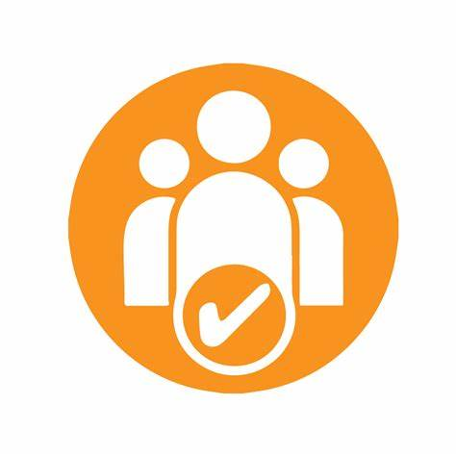
12. How does the school make sure the admissions process is fair for pupils with SEN or a disability?

For applications in the normal admissions round you should apply via www.kent.gov.uk/ola.
For In-year admissions, if there are spaces you will be offered a place. If there are no spaces your child’s name will be added to a waiting list in accordance with the oversubscription criteria.
Our admission policy states as part of the oversubscription criteria ‘All children who have an educational, health and Care Plan (EHCP) that name the school will be admitted before any other places are allocated.’
Please see our Admissions Policy for further information.

13. How does the school support pupils with disabilities?


You’re disabled under the Equality Act 2010 if you have a physical or mental impairment that has a ‘substantial’ and ‘long-term’ negative effect on your ability to do normal daily activities. Please see our Equality and Accessibility Policies for further information on how we support our pupils with disabilities.
- Equality Policy
- Accessibility-Policy-January-2023

14. How will the school support my child’s mental health and emotional and social development?

At Cecil Road Primary and Nursery School, we understand that an important feature of the school is to enable all pupils to develop emotional resilience and social skills, both through direct teaching for instance PSHE and access to a nurturing environment and indirectly, with every conversation adults have with pupils throughout the day.
We provide support for pupils to progress in their emotional and social development in the following ways:
- Pupils with SEND are encouraged to be part of the school council
- Pupils with SEND are also encouraged to be part of clubs, such as Lego Club and Multiskills, to promote teamwork/building friendships
- We have a ‘zero tolerance’ approach to bullying. Please see our Anti-bullying Policy for more information.

15. What support is in place for looked-after and previously looked-after children with SEND?


Our Deputy Headteacher, Hannah Day, is our designated teacher for looked-after children and previously looked-after children. Our Deputy Headteacher will work with our SENCO, to make sure that all teachers understand how a looked-after or previously looked-after pupil’s circumstances and their SEND might interact, and what the implications are for teaching and learning.
Pupils who are looked-after or previously looked-after will be supported much in the same way as any other child who has SEND. However, looked-after pupils will also have a personal education plan (PEP). We will make sure that the PEP and any SEND support plans or EHC plans are consistent and complement one another.

16. What support will be available for my child as they transition between classes or settings or in preparing for adulthood?
Between years

To help pupils with SEND be prepared for a new school year we:
- Ask both the current teacher and the next year’s teacher to attend the final meeting of the year when the pupil’s SEND is discussed, supported by the SENCo.
- Schedule lessons with the incoming teacher towards the end of the summer term
- Facilitate a story/play time session between the next year’s teacher and the pupil’s with SEND.
- Provide all children with social stories about their new classroom, class teacher and support staff.
Between schools
When your child is moving on from our school, we will ask you and your child what information you want us to share with the new setting.

The SENCO is invited to attend a transition event with the SENCOs of the local secondary schools. The Phase leader from the secondary school will also come into our school for a meeting with our SENCO. At both of these meetings, they will discuss the needs of all the pupils who are receiving SEND support.

Pupils will be prepared for the transition by:
- Plugging any gaps in knowledge
- Attending additional transition days/sessions


17. What support is available for me and my family?
If you have questions about SEND, or are struggling to cope, please get in touch to let us know. We want to support you, your child and your family.

- To see what support is available to you locally, have a look at Kent’s Local Offer on their website: Special Educational Needs in Kent - Local Offer

- A list of our local special educational needs and disabilities information advice and support services (SENDIASS) organisations can be found on the Kent County Council website under their Local Offer pages: SEND Directory Kent

- Local charities that offer information and support to families of pupils with SEND are:
- Information, Advice and Support (IASK)
- Kent PACT
- We Are BEAMS
- National Autistic Society (Gravesend)
- Chantry Family Hub
Further information regarding these charities can be found on the Kent County Council SEND Information Hub. SEND Information Hub - Kent

National charities that offer information and support to families of pupils with SEND are:
- IPSEA
- SEND family support
- NSPCC
- Family Action
- Special Needs Jungle

18. What should I do if I have a complaint about my child’s SEND support?
The normal arrangements for the treatment of complaints at Cecil Road Primary and Nursery School are also used for complaints regarding the provision made for Special Educational Needs. In line with our School Complaints Policy and Procedure, we encourage parents to discuss their concerns with class teachers first, followed by the SENCo and Headteacher to resolve the issue, before making the complaint formal to the Chair of the governing body.
If the complaint is not resolved or if you are not satisfied with the school’s response, you can escalate the complaint. In some circumstances, this right also applies to the pupil themselves.
To see a full explanation of suitable avenues for complaint, see pages 246 and 247 of the SEND Code of Practice.
If you feel that our school discriminated against your child because of their SEND, you have the right to make a discrimination claim to the first-tier SEND tribunal. To find out how to make such a claim, you should visit: https://www.gov.uk/complain-about-school/disability-discrimination
You can make a claim about alleged discrimination regarding:
- Admission
- Exclusion
- Provision of education and associated services
- Making reasonable adjustments, including the provision of auxiliary aids and services
Before going to a SEND tribunal, you can go through processes called disagreement resolution or mediation, where you try to resolve your disagreement before it reaches the tribunal.

19. Supporting documents

- Equailty Information and Objectives Policy
- Child Protection and Safeguarding Policy 2025
- Behaviour Policy 2025
- Accessibility Policy
- Attendance and Punctuality Policy
- SEND policy
- SEND Code of Practice 2015
- Mainstream Core Standards Kent
- Cecil Road Teaching and Learning Policy

20. Glossary
- Access arrangements – special arrangements to allow pupils with SEND to access assessments or exams
- Annual review – an annual meeting to review the provision in a pupil’s EHC plan
- Area of need – the 4 areas of need describe different types of needs a pupil with SEND can have. The 4 areas are communication and interaction; cognition and learning; physical and/or sensory; and social, emotional and mental health needs.
- CAMHS – child and adolescent mental health services
- Differentiation – when teachers adapt how they teach in response to a pupil’s needs
- EHC needs assessment – the needs assessment is the first step on the way to securing an EHC plan. The local authority will do an assessment to decide whether a child needs an EHC plan.
- EHC plan – an education, health and care plan is a legally-binding document that sets out a child’s needs and the provision that will be put in place to meet their needs.
- First-tier tribunal/SEND tribunal – a court where you can appeal against the local authority’s decisions about EHC needs assessments or plans and against discrimination by a school or local authority due to SEND
- Graduated approach – an approach to providing SEND support in which the school provides support in successive cycles of assessing the pupil’s needs, planning the provision, implementing the plan, and reviewing the impact of the action on the pupil
- Intervention – a short-term, targeted approach to teaching a pupil with a specific outcome in mind
- Local offer – information provided by the local authority which explains what services and support are on offer for pupils with SEND in the local area
- Outcome – target for improvement for pupils with SEND. These targets don't necessarily have to be related to academic attainment
- Reasonable adjustments – changes that the school must make to remove or reduce any disadvantages caused by a child’s disability
- SENCO – the special educational needs co-ordinator
- SEN – special educational needs
- SEND – special educational needs and disabilities
- SEND Code of Practice – the statutory guidance that schools must follow to support pupils with SEND
- SEND information report – a report that schools must publish on their website, that explains how the school supports pupils with SEND
- SEND support – special educational provision which meets the needs of pupils with SEND
- Transition – when a pupil moves between years, phases, schools or institutions or life stages

