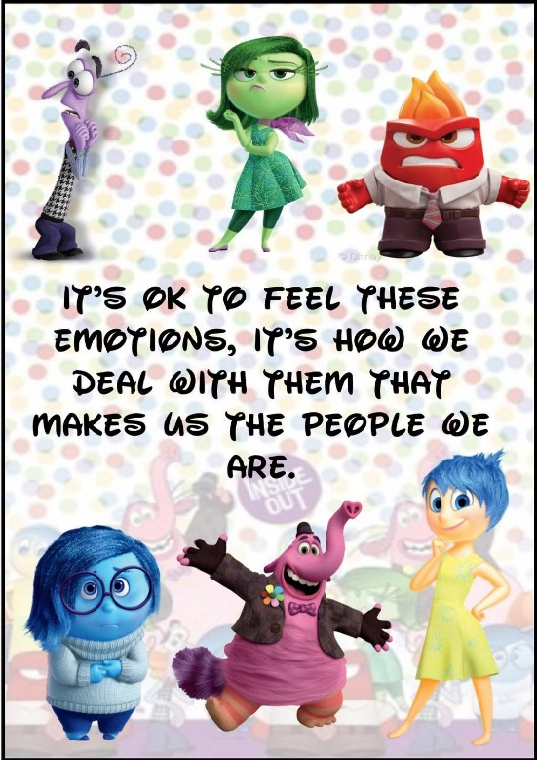

A Parent’s Guide to Zones of Regulation

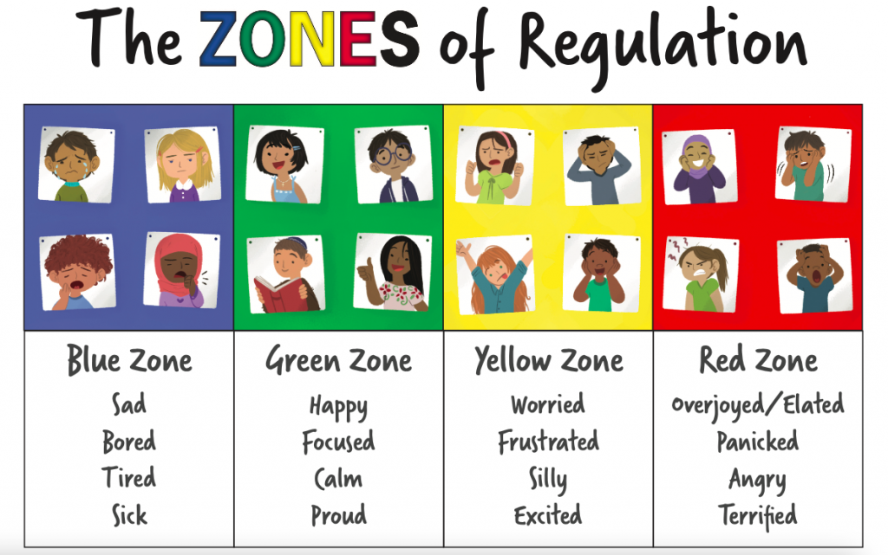

What is Zones of Regulation?
The Zones of Regulation helps children to manage difficult emotions, known as ‘self-regulation’.
Self-regulation is best described as the best state of alertness for a situation, or the ability to maintain a well regulated emotional state to cope with everyday stress and to be most available for learning and interacting. From time to time, all of us (including adults) find it hard to manage strong feelings such as worry, anger, restlessness, fear or tiredness, and this stops us from getting on with our day effectively. Children who feel these emotions often find it hard to learn and concentrate in school. The Zones of Regulation aims to teach children strategies to help them to identify their emotions and cope with these feelings so they can get back to feeling calm and ready to learn. These coping strategies are called ‘selfregulation’.
At Cecil Road Primary and Nursery School, we want to teach all of our children good coping and regulation strategies so they can help themselves when they experience anxiety and stress. Each class is taught about the zones and uses them in the most age-appropriate way. Using the Zones of Regulation as a framework, we aim to help children to:
• Recognise when they are in the different Zones and learn how to change or stay in the Zone they are in.
• Increase their emotional vocabulary so they can explain how they are feeling.
• Recognise when other people are in different Zones, thus developing better empathy.
• Develop an insight into what might make them move into the different Zones.
• Understand that emotions, sensory experiences such as lack of sleep or hunger and their environment might influence which Zone they are in.
• Develop problem-solving skills and resilience
• Identify a range of calming and alerting strategies that support them (known as their personal ‘toolkit’).

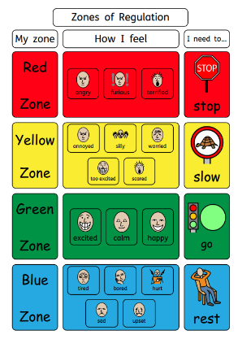
What are the different Zones?

There are 4 coloured zones to categorise states of alertness and emotional states:
✓ The Blue Zone – used to describe low states of alertness, (such as feeling sad, tired, sick or bored. Body/brain is moving sluggishly).
✓ The Green Zone – used to describe a regulated state of alertness (such as feeling calm, happy, focussed or content). This zone is generally needed for school work, being social and ready to learn. It shows control.
✓ The Yellow Zone – used to describe a heightened state of alertness, but with some control (such as when experiencing stress, frustration, anxiety, excitement, silliness, nervousness, confusion - slightly elevated emotions (being fidgety, wiggly, squirmy or sensory seeking). The person is starting to lose control.
✓ The Red Zone – used to describe extremely heightened states of alertness or very intense feelings (such as feeling anger, rage, and explosive behaviour, panic, terror or elation). Not being in control of one’s own body.
You can remember the zones by using a traffic light system.

Like traffic signs;
Blue = ‘rest area where you pull over as you are tired and need to recharge’.
Green = the person is ‘good to go’
Yellow = ‘caution, slow down or take warning’
Red = ‘stop and regain control

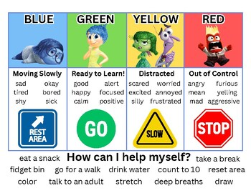

No zone is ‘bad’ or ‘good’ and we all experience them at one time or another. It is important to avoid reinforcing the idea that red = bad. Often we see with our children that they will indicate they’re in the green zone, even if they’re not.
It is important to validate all emotions, and we should be helping our students to identify these emotions.

Tools and Strategies for Regulation
There are multiple tools and strategies that our children can use to self-regulate – and they will be individual to each child. However, it may be useful to think about the types of activities that will help our children to regulate in each zone.
Blue Zone Tools:
✓ Think about what you might do as an adult to make you feel better when you are sad, tired or bored.
✓ This might include talking to a trusted person, breathing, taking a break and relaxing, doing a hobby or importantly, doing some physical exercise.
✓ These exercises should wake up our bodies, recharge and activate our senses and regain our focus. Examples may include: taking a walk, doing some active movement (think jumping, bouncing or swinging).

Green Zone Tools:
✓ Think about the strategies you or your child uses to maintain your happiness, alertness in the activity you are engaging in, and calmness.
✓ This may include all of the activities mentioned above, and also pay attention to the environment your child is in – is it safe, calm and enabling of engagement.

Yellow Zone Tools:
✓ When you see your child starting to become heightened, fidgety, overexcited or unfocussed – try to introduce the following calming strategies to prevent an escalation into the Red Zone (or out of control).
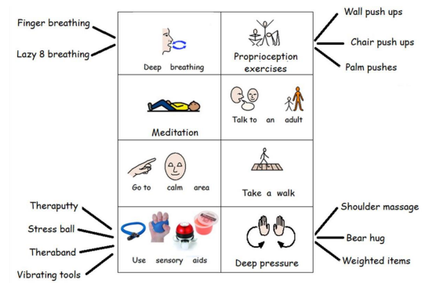

Red Zone Tools:
✓ Once in the Red Zone, your child will more than likely need to be removed from the situation/setting, and it is encouraged that they go to an environment that is calming and safe.
✓ Calming strategies that ‘power down’ the emotions your child is feeling can be practiced here. These include:
- Deep breathing
- Deep pressure/heavy work activities
- Sensory activities – using sensory aids and tools such as theraputty, stress balls, vibrating snakes etc.
- Taking a walk in a quiet place
- Going to a quiet and dark area (i.e. pillow fort/dark tent)
✓ Minimise your language when your child is in the red zone – be clear, concise and calm in your tone.

How can you help your child use The Zones of Regulation at home?
✓ Model and identify your own feelings using Zones language in front of your child (e.g.: I’m frustrated. I think I am in the Yellow Zone.”)
✓ Observe your child’s behaviour and try to use strategies when they are showing signs of being in the yellow zone, to catch it before they move to the red zone.
✓ Practice calming strategies when your child is in the green zone. This may include doing some deep breathing/meditation/heavy work and sensory activities throughout their day.
✓ Talk about what tool you will use to be in the appropriate Zone (e.g.: “I need to take four deep breaths to help get me back to the Green Zone.”)
✓ At times, wonder which Zone your child is in. Or, discuss which Zone a character in a film / book might be in. (e.g.: “You look sleepy. Are you in the Blue Zone?”)
✓ Share how their behaviour is affecting your Zone. For example, if they are in the Green Zone, you could comment that their behaviour is also helping you feel happy/ go into the Green Zone.
✓ Put up and reference the Zones visuals and tools in your home to consistently refer to and check in regularly with this
✓ Praise and encourage your child when they share which Zone they are in.
✓ Develop your child’s own zones of regulation tool box – using the exercises above
✓ Have easy access to calming/sensory equipment at home
✓ Remember to monitor your language: o usually less is best (minimal in the red zone)
Tips for helping your child to regulate
• Know yourself and how you react in difficult situations before dealing with your child’s behaviours. • Know your child’s sensory threshold. We all process sensory information differently and it impacts our reactivity to situations.
• Know your child’s triggers.
• Be consistent in managing your child’s behaviour and use the same language you use at home.
• Empathise with your child and validate what they are feeling.
• Have clear boundaries/routines and always follow through.
• Do not deal with an angry, upset child when you are not yet calm yourself.
• Discuss strategies for the next time when you are in a similar situation.
• Remember to ask your child how their choices made you feel (empathy).
• Praise your child for using strategies. Encourage your child to take a sensory break to help regulate their bodies.
• Create a ‘calm’ box or ‘sensory box’ full of things which help to keep your child calm and alert.

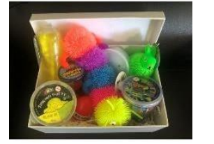

Where can I find out more?
Click here for a Video The Zones of Regulation | A Curriculum For Emotional Regulation



